# Final Use Case

## Project Overview

This project demonstrates the complete DevOps lifecycle by building, containerizing, and deploying a simple "Hello World" web application on Azure Free Tier. The implementation includes infrastructure setup, containerization with Docker, Azure Kubernetes Service (AKS) deployment, and CI/CD automation using Azure DevOps.

## Architecture Overview

* **Azure Resource Group**: DevEnvironment-RG (centralized resource management)
* **Virtual Network**: Dev-VNet (10.0.0.0/16) with Dev-Subnet (10.0.1.0/24)
* **Virtual Machine**: Ubuntu 24.04 LTS (development environment)
* **Azure Container Registry**: For storing Docker images
* **Azure Kubernetes Service**: Container orchestration platform
* **Azure DevOps**: CI/CD pipeline automation

## Phase 1: Infrastructure Setup

### 1.1 Resource Group Creation

**Command Used**: az group create --name DevEnvironment-RG --location "East US"

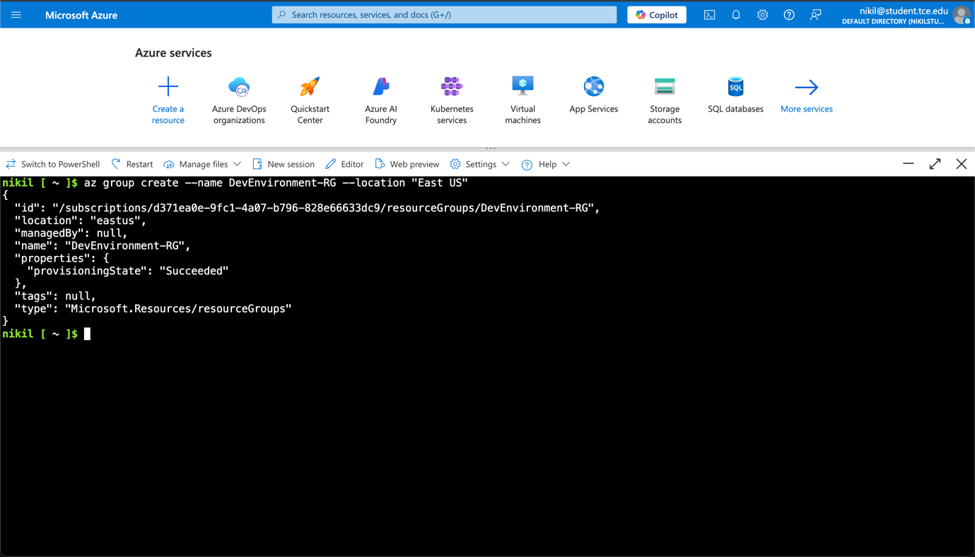

Successfully created the **DevEnvironment-RG** resource group in **East US** region. This serves as the logical container for all project resources, enabling centralized management and cost tracking. The resource group provides a unified lifecycle management approach where all resources can be managed, monitored, and deleted together.

### 1.2 Virtual Network (VNet) Setup

**Command Used**:

az network vnet create \

--name Dev-VNet \

--resource-group DevEnvironment-RG \

--address-prefix 10.0.0.0/16

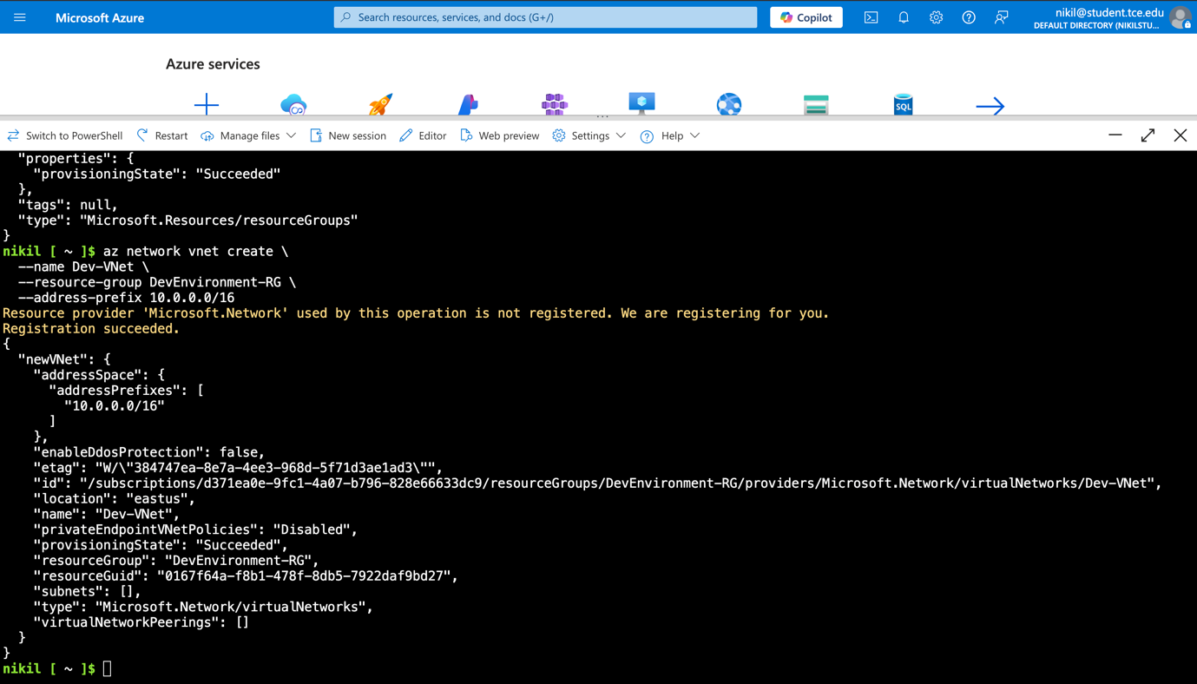

Created Dev-VNet with address space 10.0.0.0/16, providing a private network environment in Azure. This VNet enables secure communication between Azure resources and allows for network segmentation. The /16 subnet mask provides approximately 65,534 IP addresses, which is sufficient for this development environment and future scaling needs.

### 1.3 Subnet Configuration

**Command Used**:

az network vnet subnet create \

--vnet-name Dev-VNet \

--resource-group DevEnvironment-RG \

--name Dev-Subnet \

--address-prefix 10.0.1.0/24

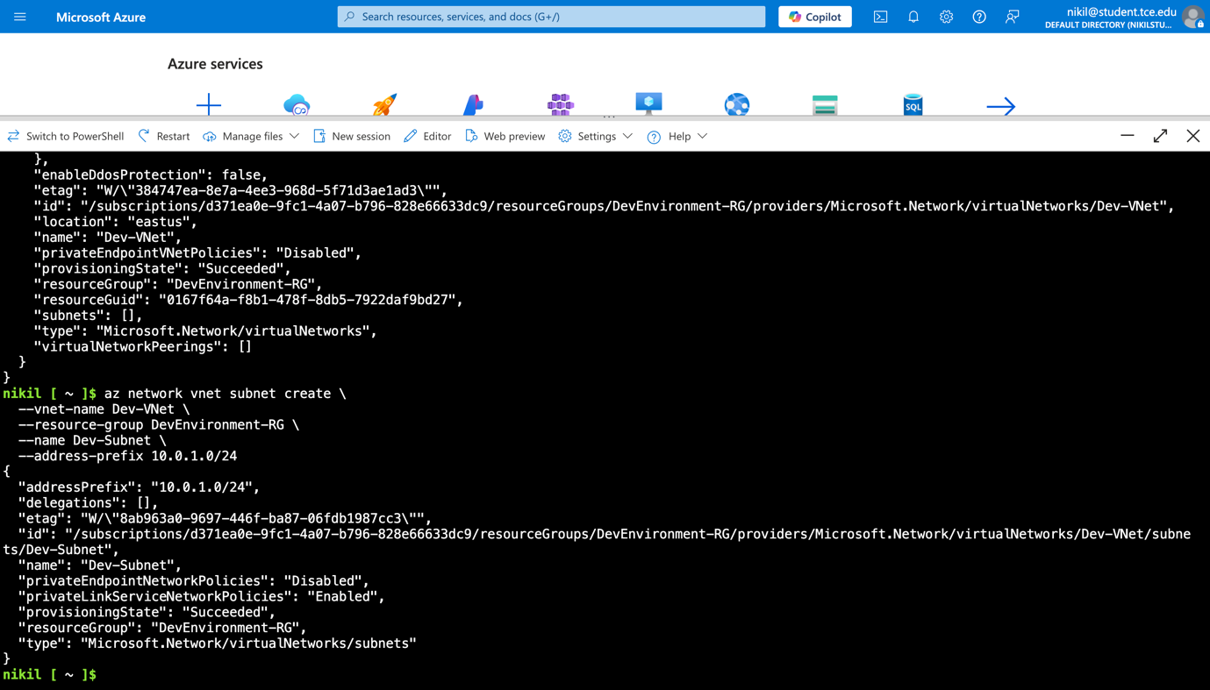

Created Dev-Subnet with address range 10.0.1.0/24 within the Dev-VNet. This subnet provides 254 usable IP addresses for resources. Subnetting allows for better network organization, security control, and resource isolation within the virtual network.

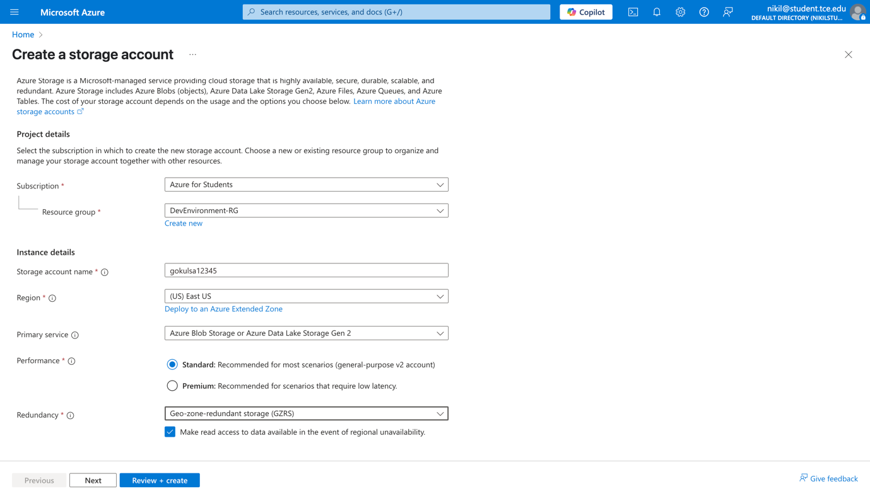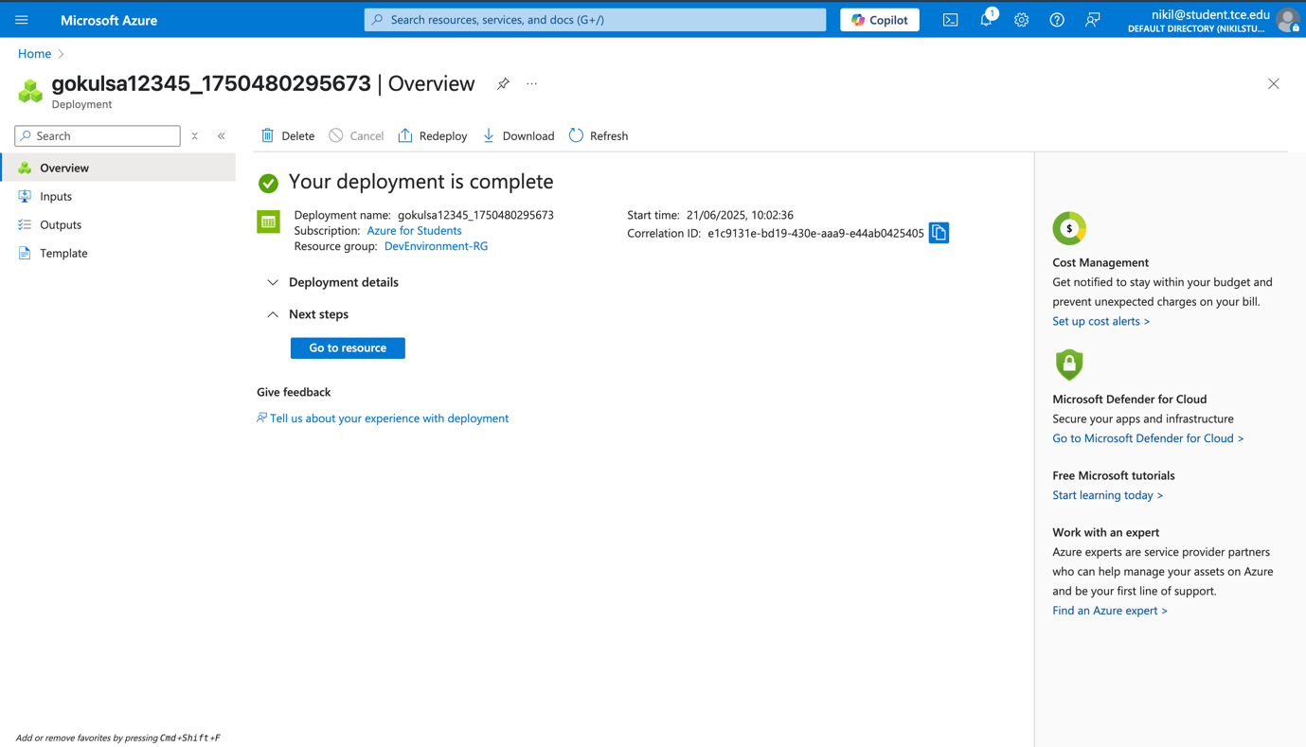

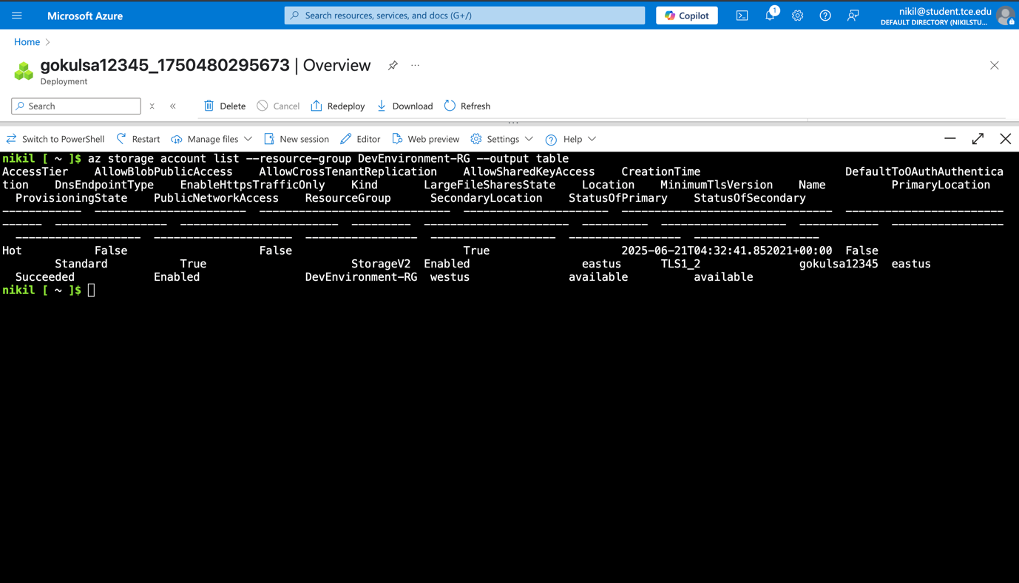

### 1.4 Virtual Machine Deployment

**Command Used**:

az vm create \

--resource-group DevEnvironment-RG \

--name Dev-VM \

--image Ubuntu2404 \

--size Standard_B1s \

--admin-username azure-dev-user \

--generate-ssh-keys \

--vnet-name Dev-VNet \

--subnet Dev-Subnet

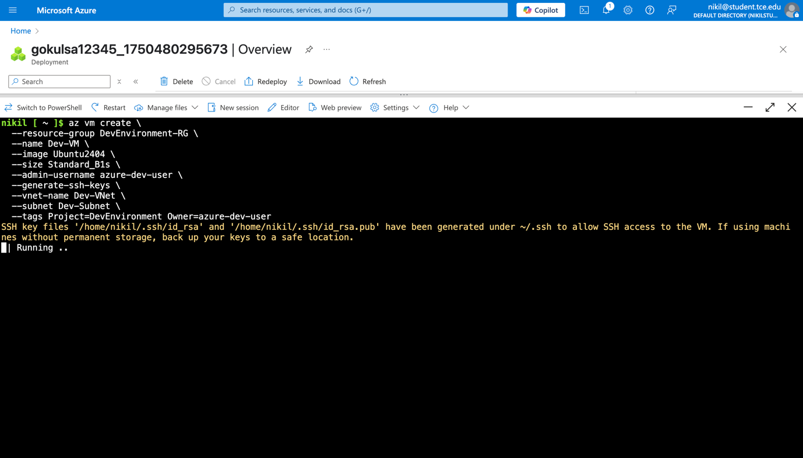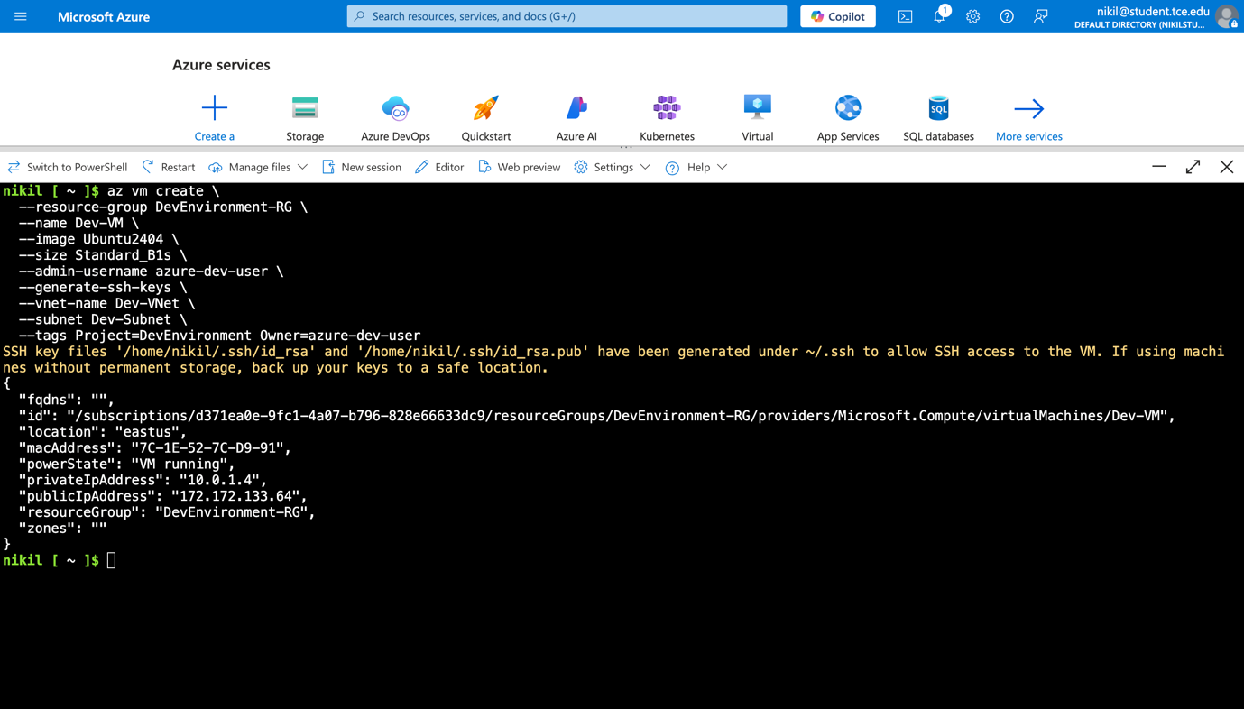

Successfully deployed Ubuntu VM with Standard_B1s size, which falls within Azure Free Tier limits. The VM serves as the development environment for building and testing the application. SSH key authentication was automatically generated for secure access. The VM is connected to the Dev-Subnet, ensuring it receives an IP address from the 10.0.1.0/24 range.

## Phase 2: Network Security Configuration

### 2.1 Network Security Group Creation

**Commands Used**:

az network nsg create --resource-group DevEnvironment-RG --name Dev-NSG

az network nsg rule create \

--resource-group DevEnvironment-RG \

--nsg-name Dev-NSG \

--name Allow-HTTP \

--priority 100 \

--direction Inbound \

--access Allow \

--protocol Tcp \

--destination-port-ranges 80

az network nsg rule create \

--resource-group DevEnvironment-RG \

--nsg-name Dev-NSG \

--name Allow-SSH \

--priority 110 \

--direction Inbound \

--access Allow \

--protocol Tcp \

--destination-port-ranges 22

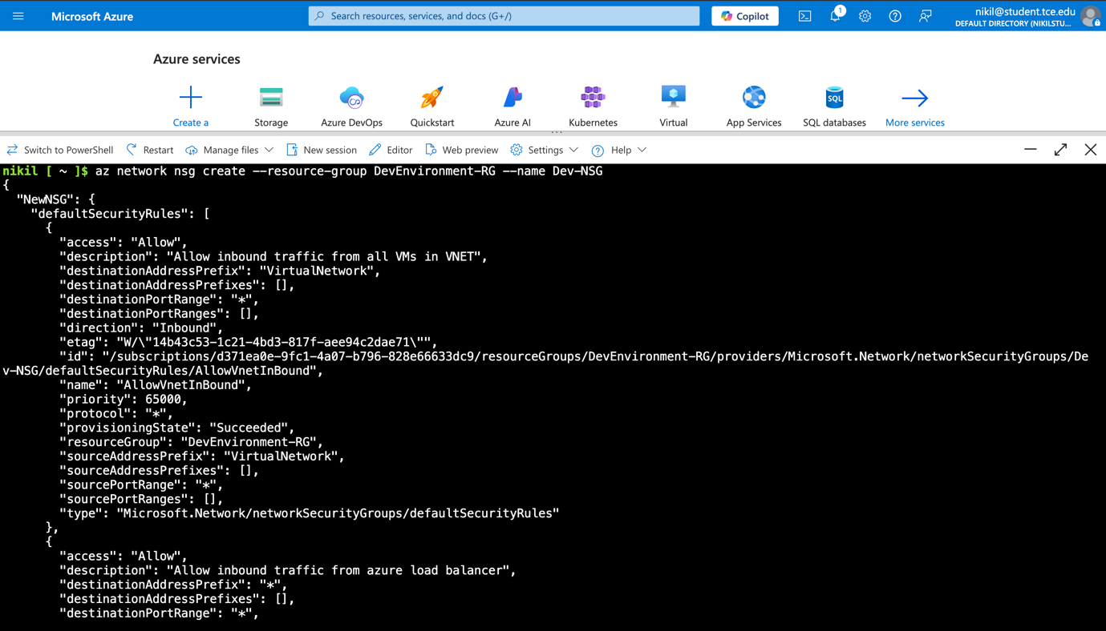

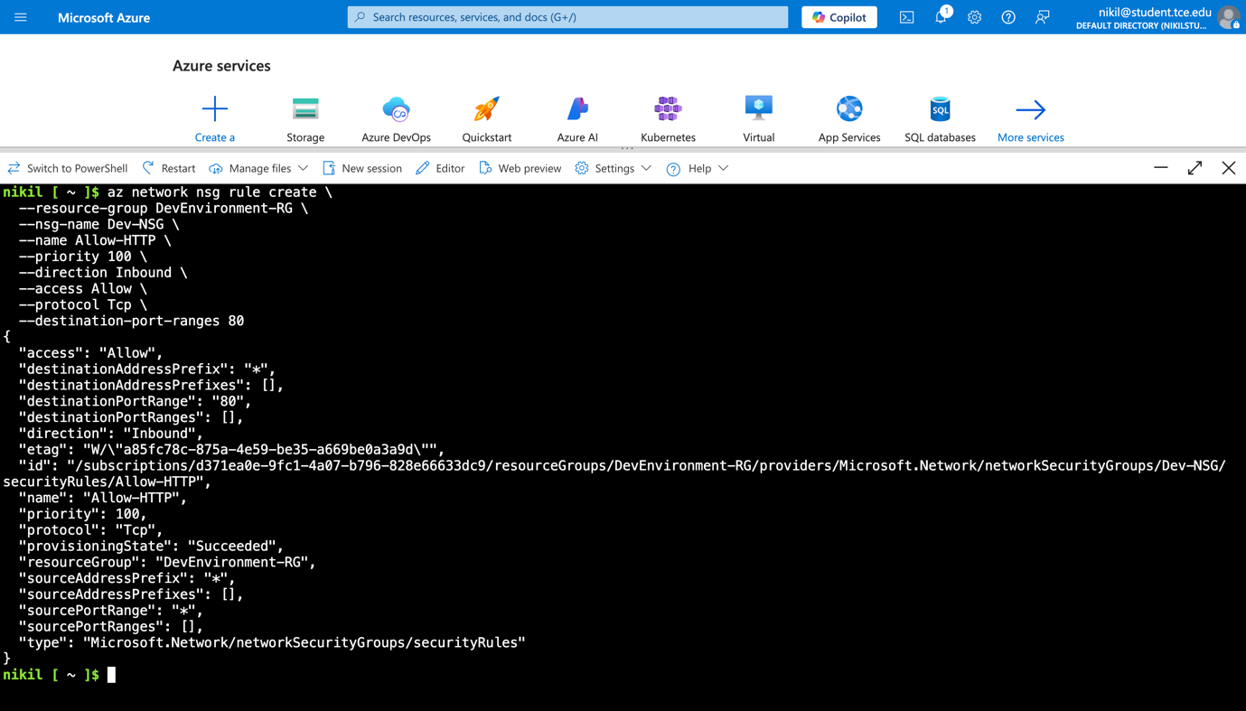

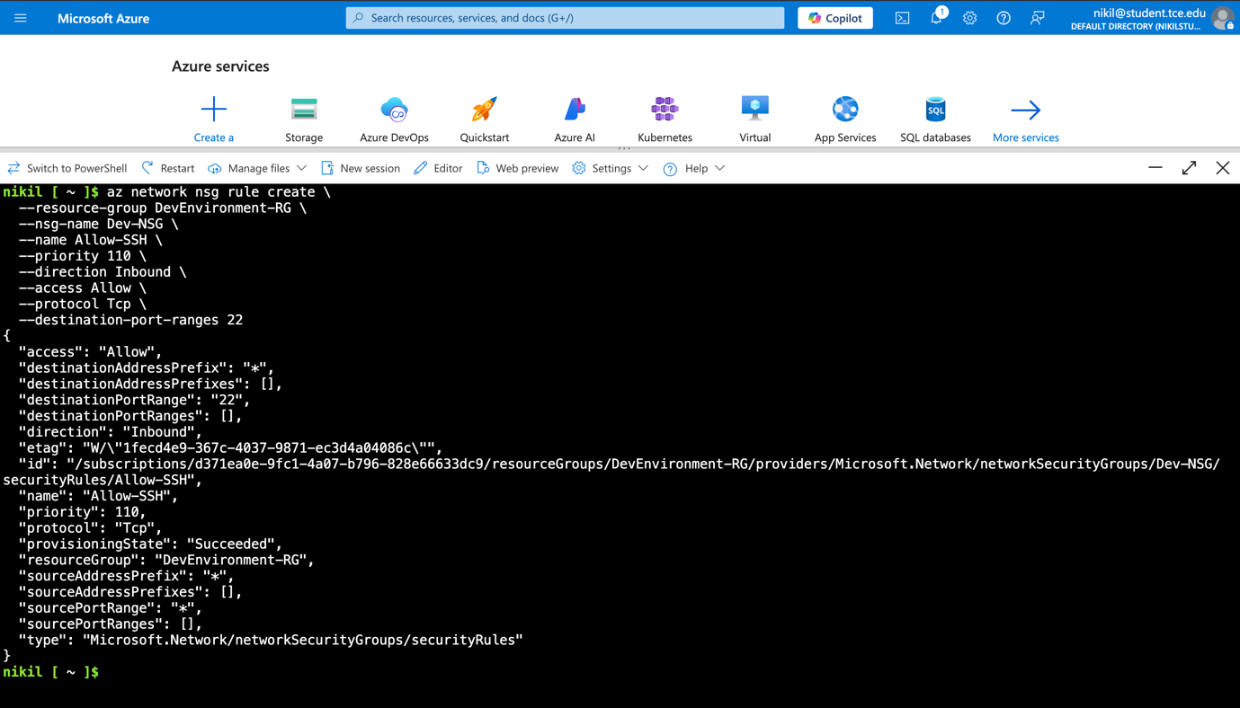

Created Network Security Group with essential security rules. The NSG acts as a virtual firewall controlling inbound and outbound traffic. Two critical rules were implemented:

* **HTTP Rule (Priority 100)**: Allows web traffic on port 80 for serving the web application
* **SSH Rule (Priority 110)**: Enables secure shell access on port 22 for VM management

The priority system ensures HTTP traffic is evaluated first, and both rules use TCP protocol for reliable communication.

## Phase 3: Development Environment Setup

### 3.1 VM Connection and Initial Setup

**SSH Connection**: Successfully connected to the VM using the generated SSH key pair.

**Documentation**: Established secure SSH connection to the development VM. This connection provides command-line access to the Ubuntu environment where all development tools and application components will be installed and configured.

### 3.2 System Updates and Docker Installation

**Commands Executed**:

sudo apt update

sudo apt install -y docker.io

sudo systemctl start docker

sudo systemctl enable docker

sudo usermod -aG docker azure-dev-user

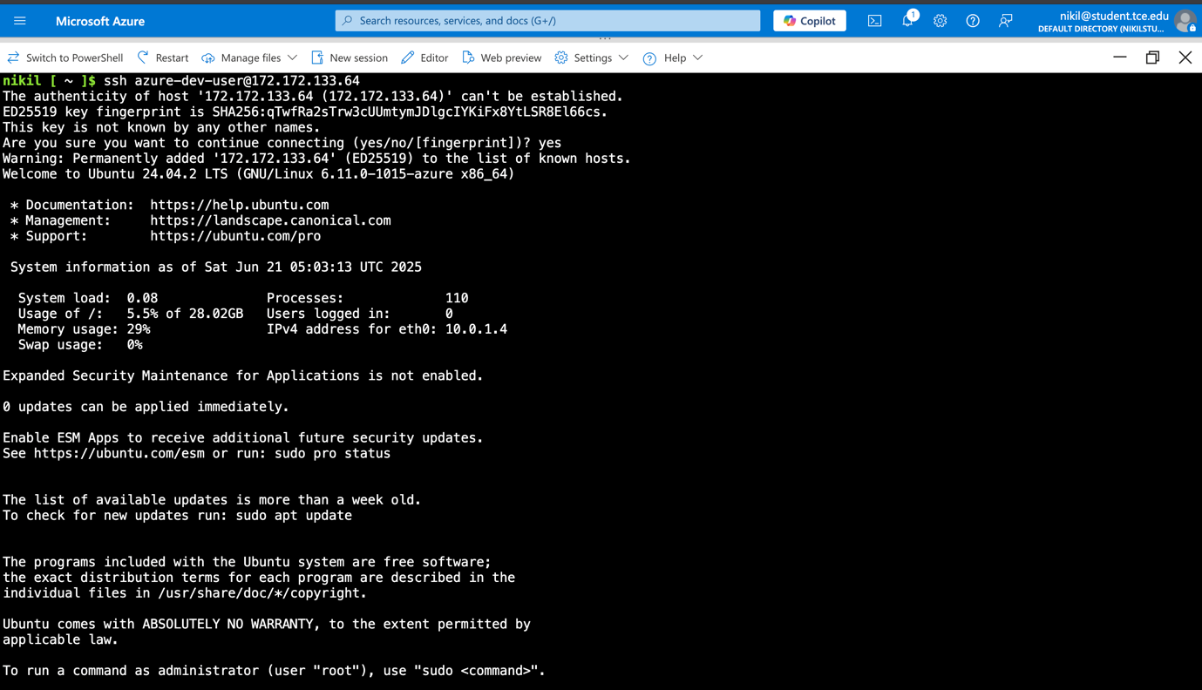

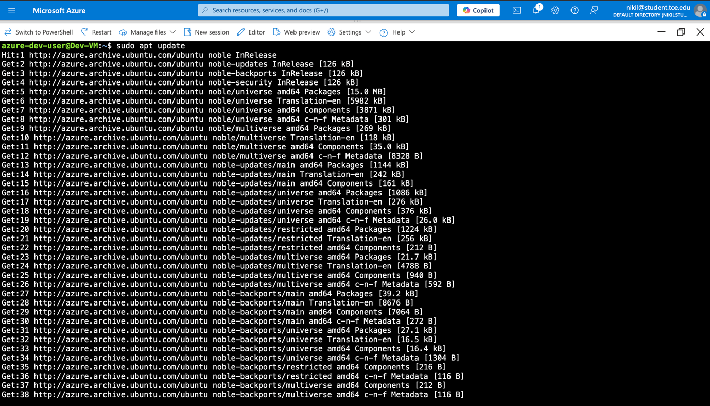

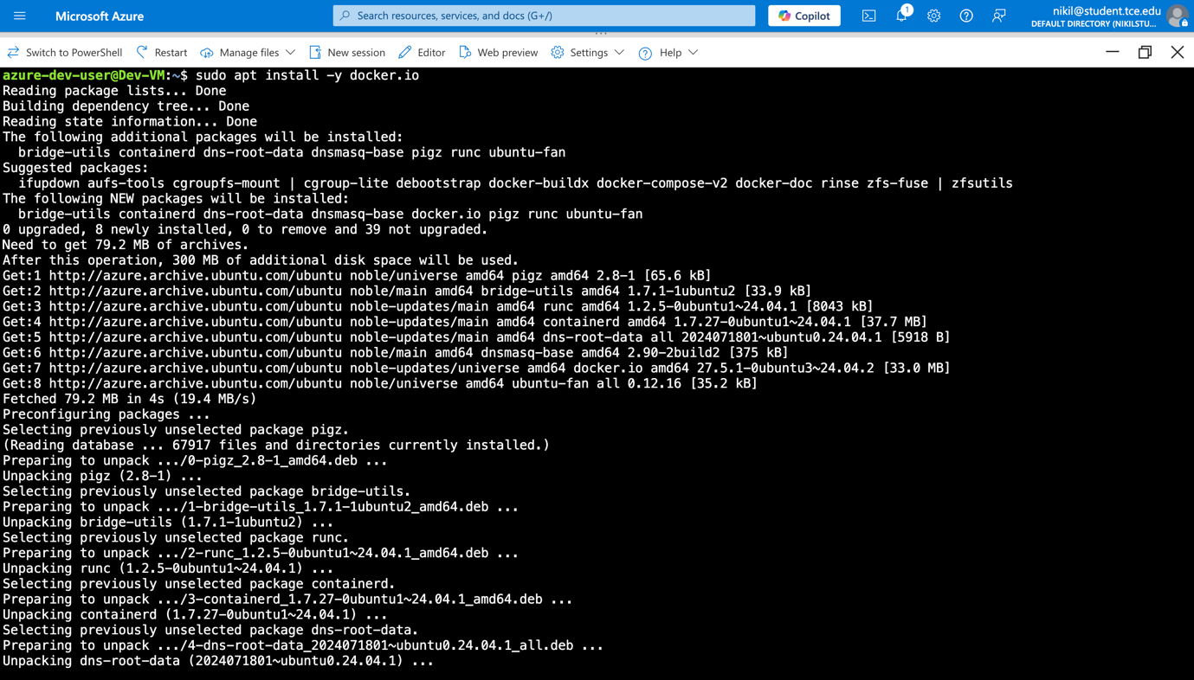

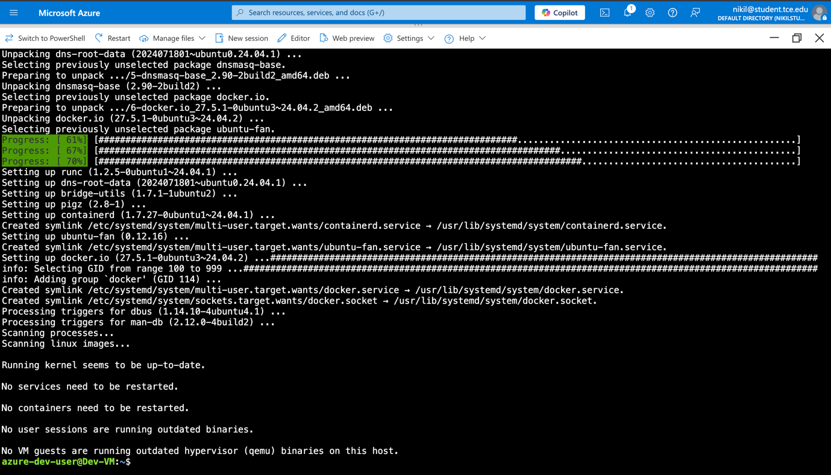

Installed Docker.io package for container management

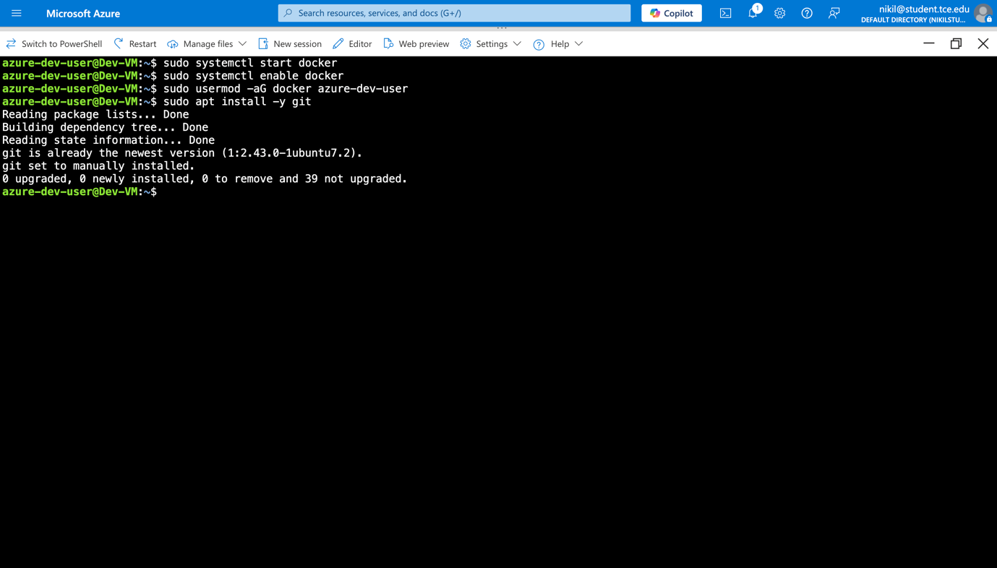

Installed Git version control system for source code management. Git enables version tracking, collaboration, and integration with Azure DevOps repositories.

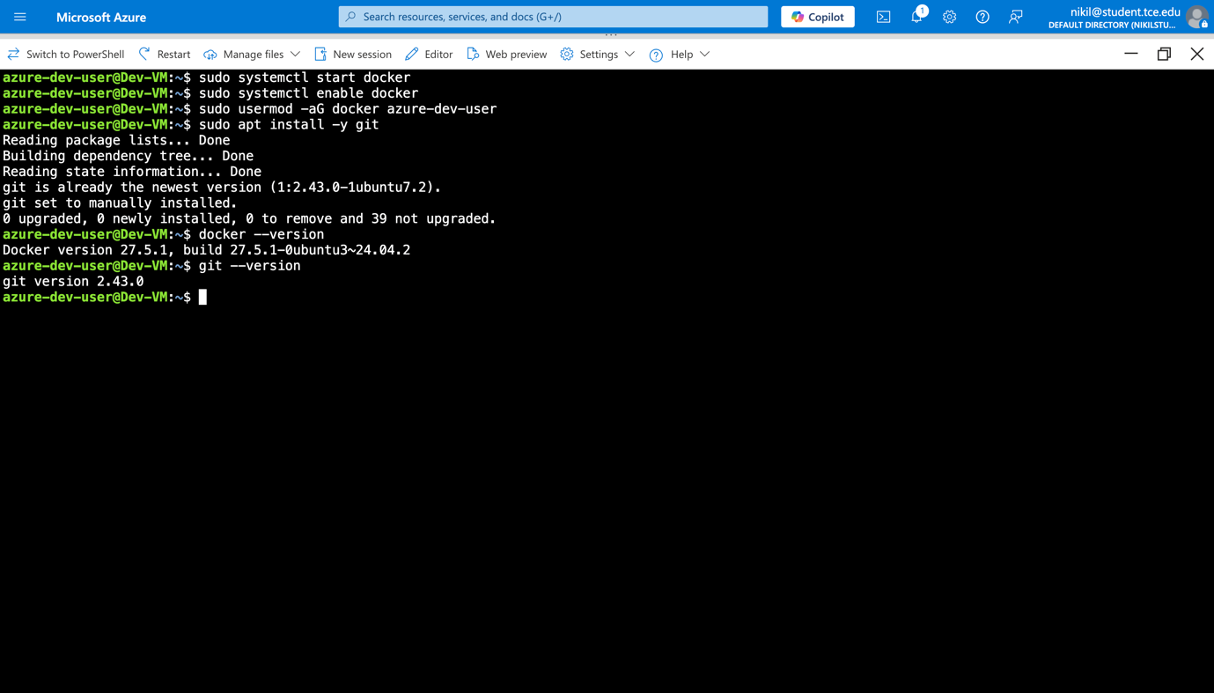

Here, we are checking the installed version of Git VCS and Docker

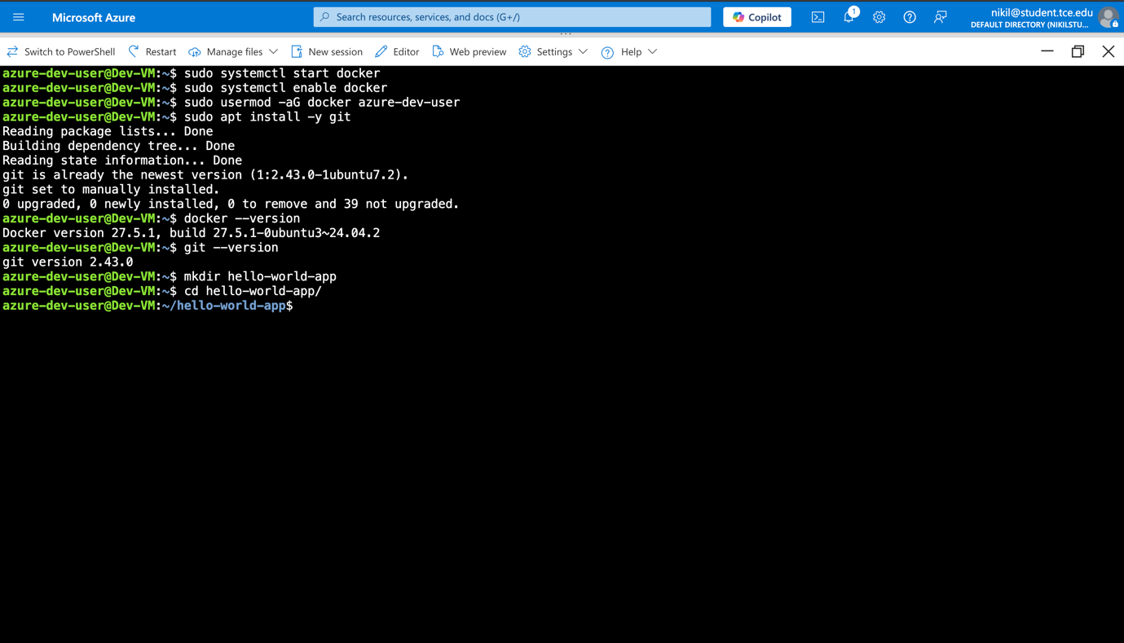

We are creating a directory named hello-world-app and we will create two files named index.html and Dockerfile

## Phase 4: Application Development

### 4.1 Application Structure

**Directory**: hello-world-app **Files Created**:

* index.html (main application file)
* Dockerfile (containerization configuration)

### 4.2 HTML Application Content

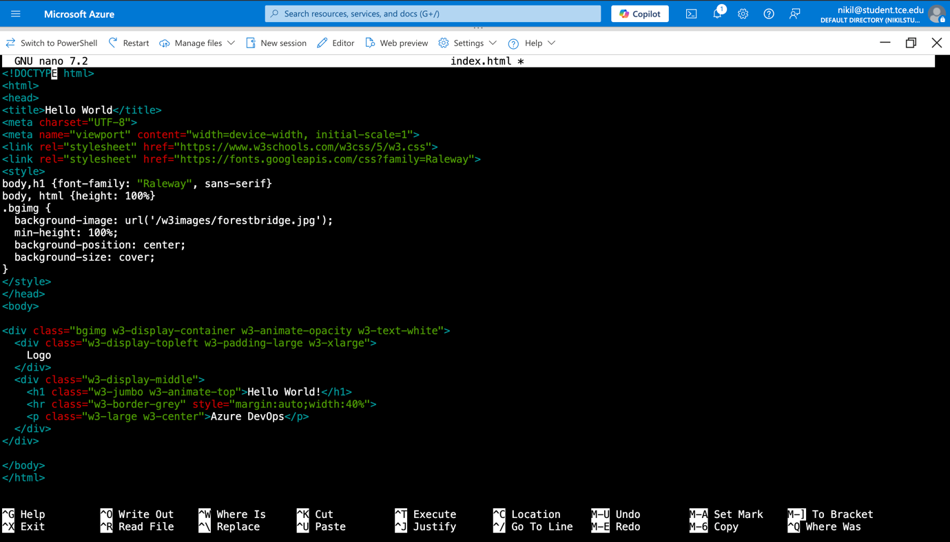

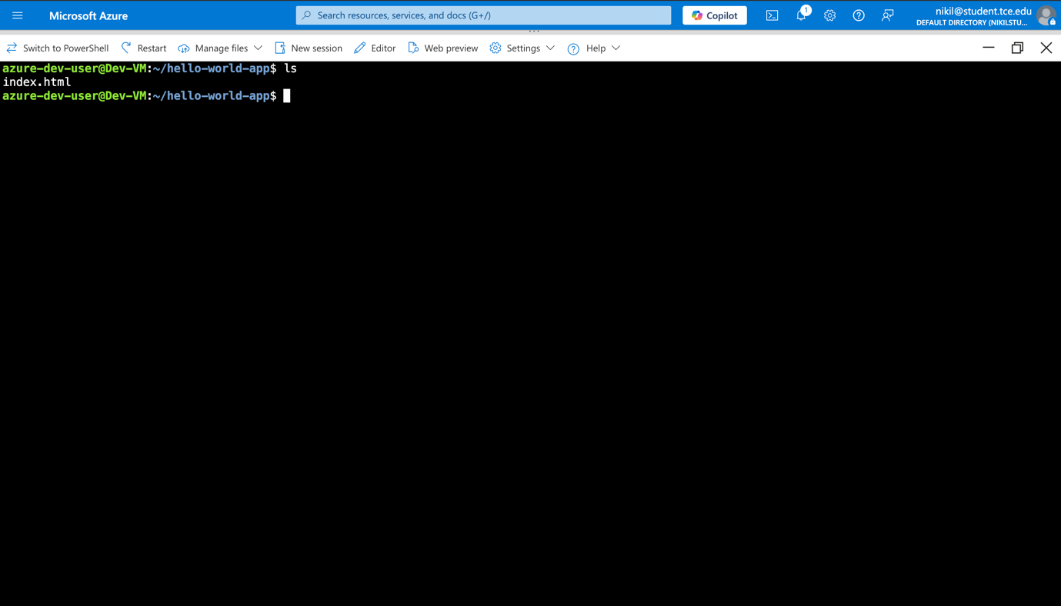

### 4.3 Dockerfile Configuration

dockerfile

FROM nginx:latest

COPY . /usr/share/nginx/html

EXPOSE 80

CMD ["nginx", "-g", "daemon off;"]

**Documentation**: Created Dockerfile using Nginx base image for serving static content. The configuration:

* Uses latest stable Nginx image for reliability and security
* Copies application files to Nginx default web root
* Exposes port 80 for HTTP traffic
* Runs Nginx in foreground mode for container compatibility

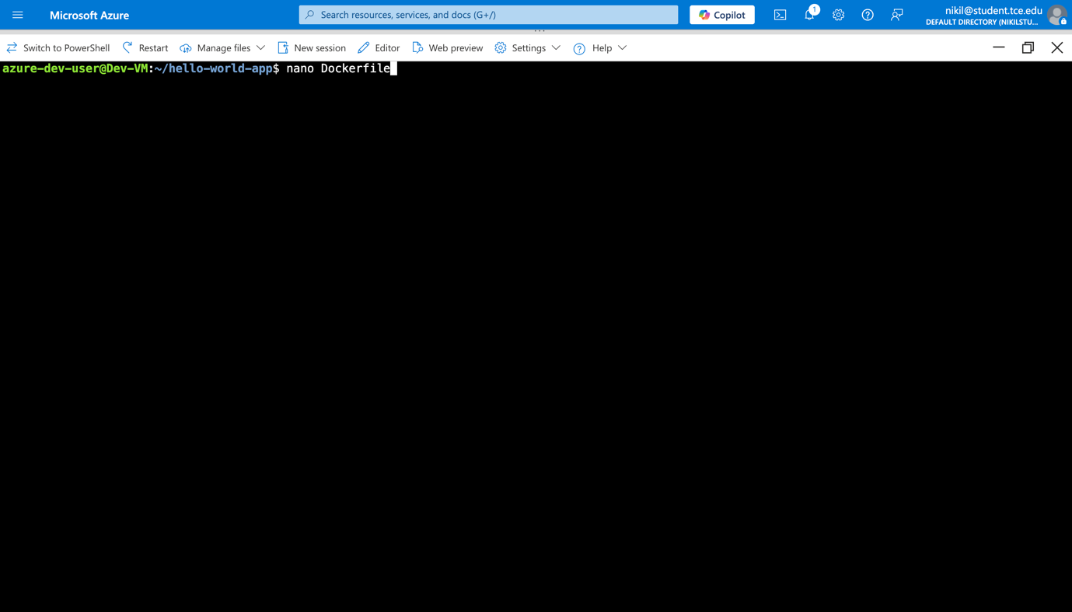

Creating a Dockerfile with nano

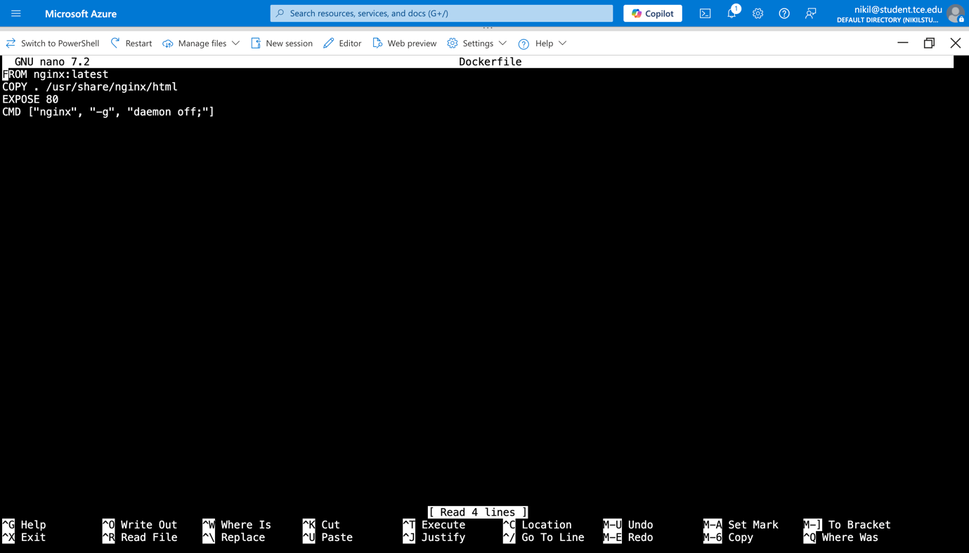

Content of the Dockerfile

## Phase 5: Containerization

### 5.1 Docker Image Build

**Command**: docker build -t hello-world-app .

**Documentation**: Successfully built Docker image named 'hello-world-app' from the Dockerfile. The build process:

* Downloaded Nginx base image layers
* Copied application files into the image
* Configured the container for web serving
* Created a portable, immutable deployment artifact

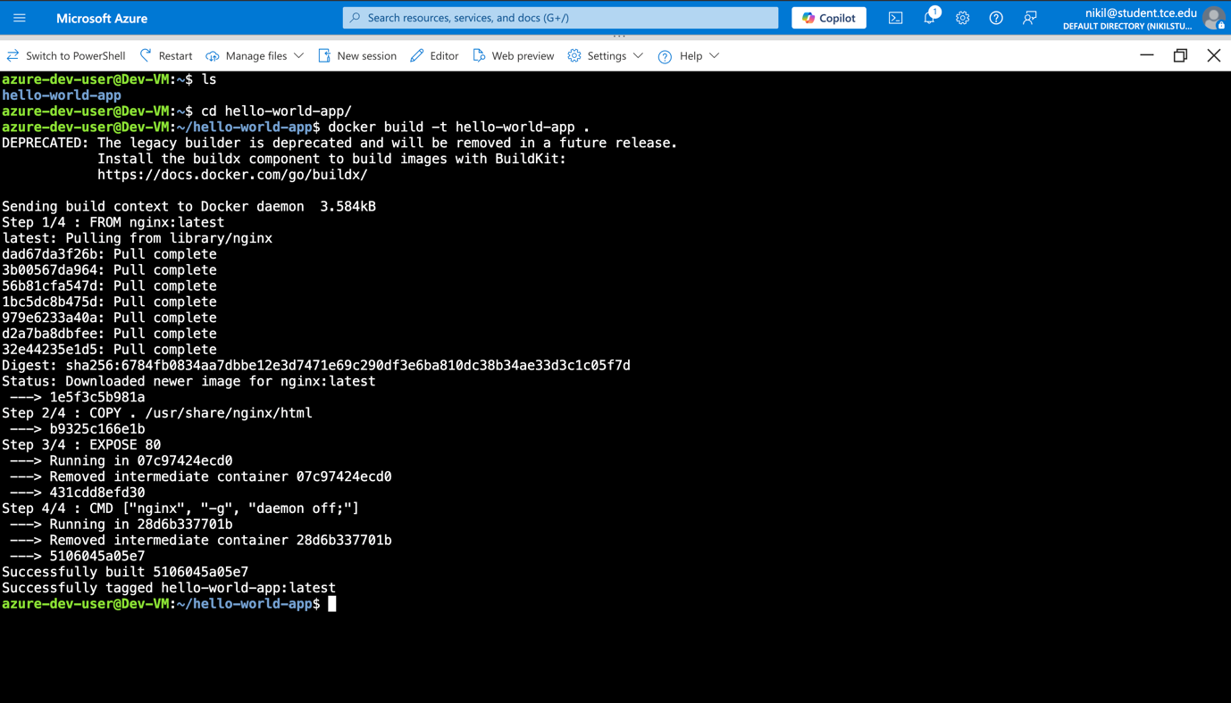

Building the Docker Image

### 5.2 Docker Image Verification

**Command**: docker images

**Documentation**: Verified the created Docker image appears in the local registry with proper tagging. This confirms the build process completed successfully and the image is ready for testing or deployment.

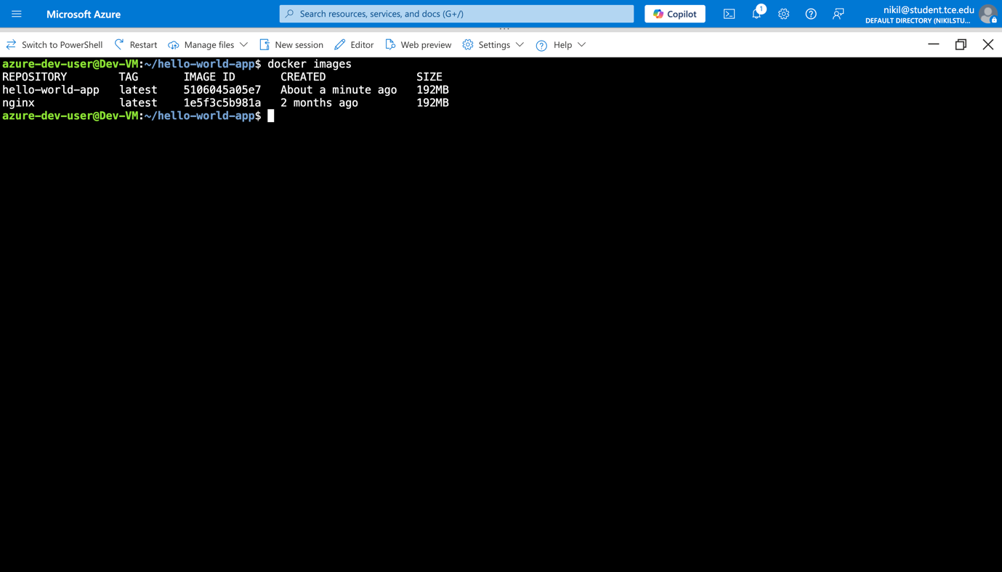

Using the docker images command to see the existing images in the VM.

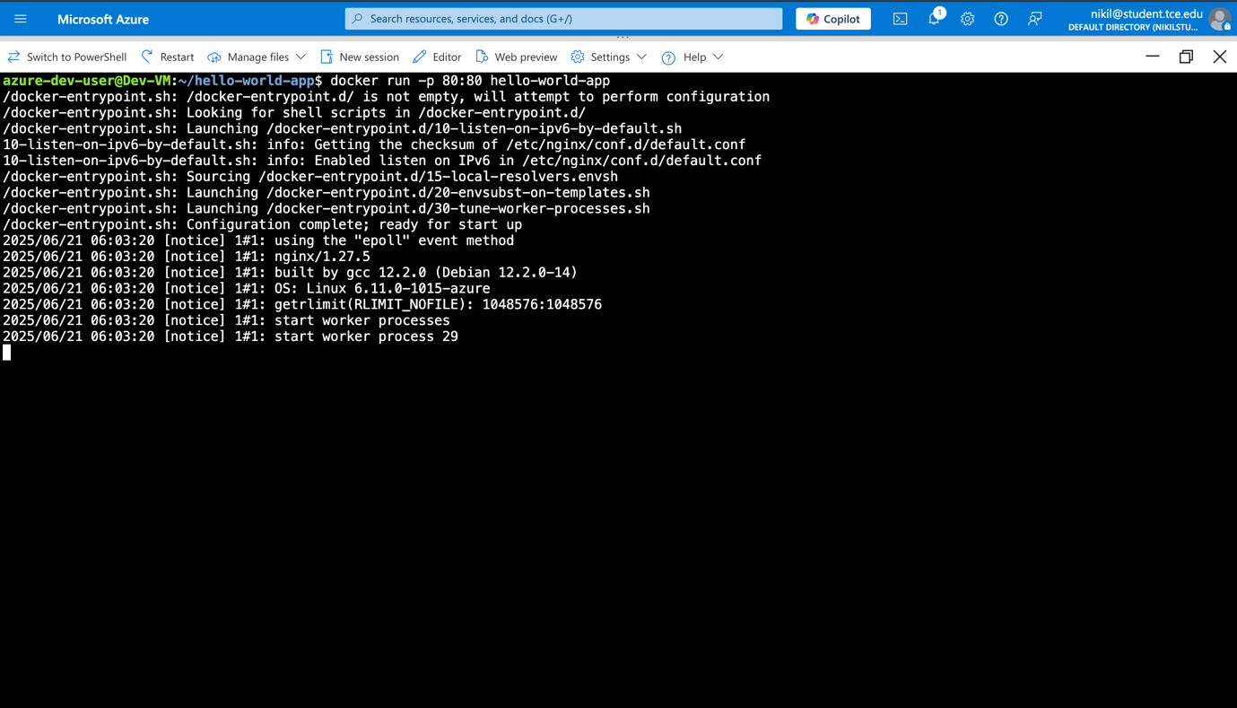

## Phase 6: Azure Container Registry Setup

### 6.1 ACR Creation Challenges

**Initial Issues Encountered**: During ACR creation, encountered naming conflicts and resource allocation errors.

**Resolution Process**:

1. Identified naming convention requirements for ACR
2. Selected unique registry name: gokul0880acr
3. Successfully created ACR with Basic SKU for cost optimization

**Final Command**:

az acr create \

--resource-group DevEnvironment-RG \

--name gokul0880acr \

--sku Basic

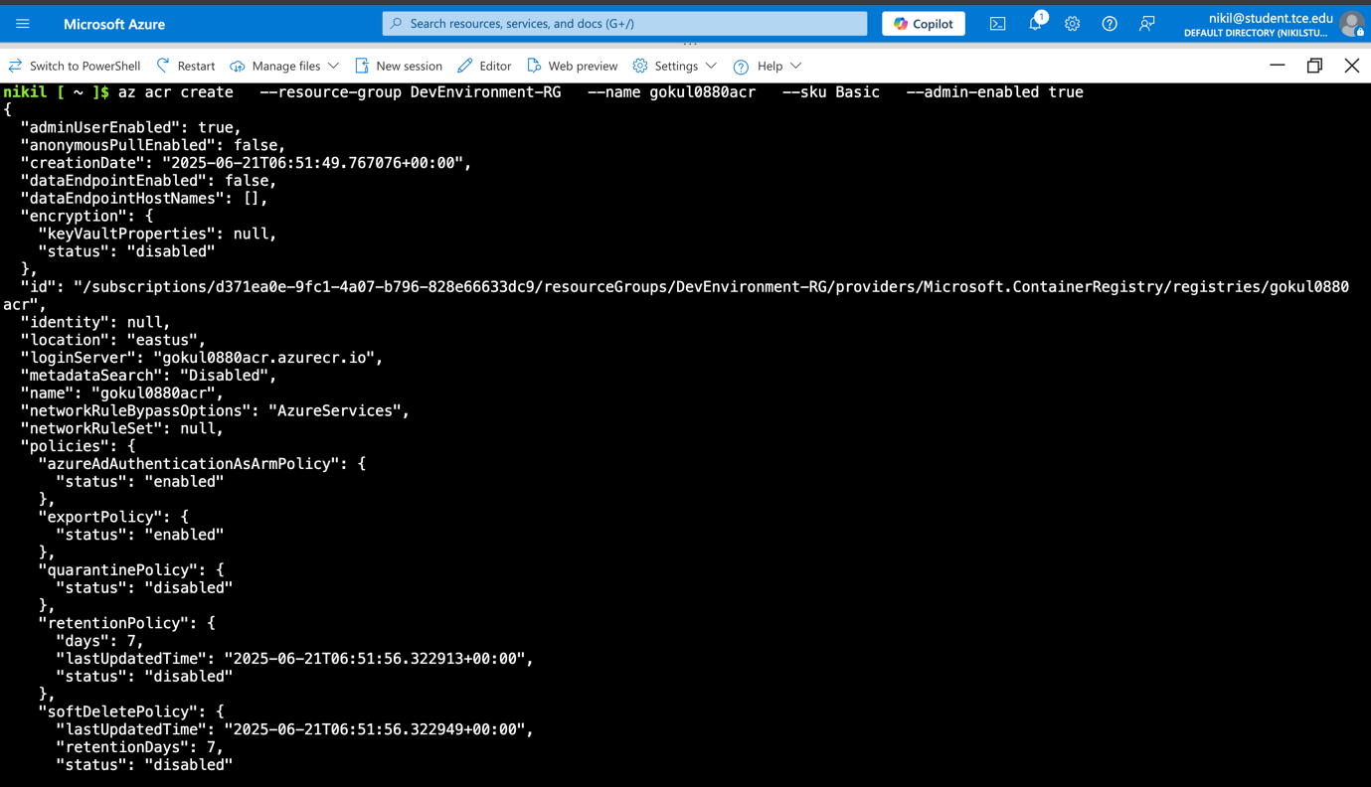

ACR created

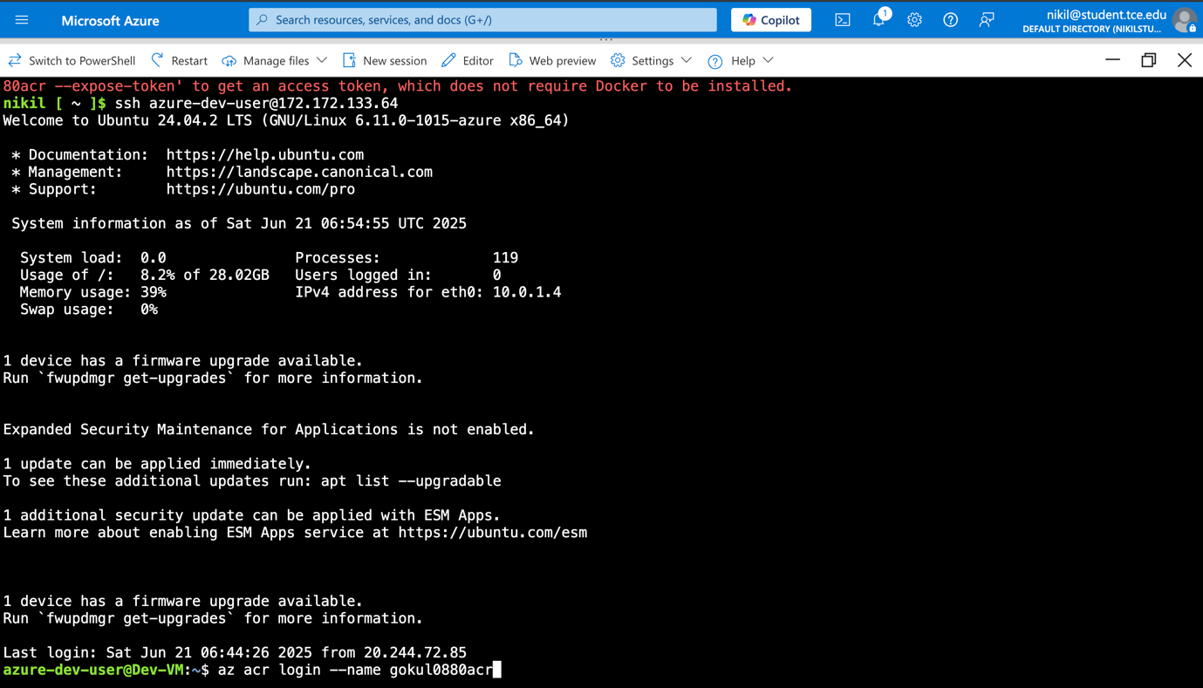

After resolving initial naming conflicts, successfully created Azure Container Registry. The Basic SKU was selected for cost-effectiveness while providing necessary functionality for development scenarios. This private registry will store and manage Docker images securely within the Azure environment.

### 6.2 Azure CLI Integration

**Setup Process**:

1. Installed Azure CLI within the VM environment
2. Authenticated with Azure account
3. Selected appropriate subscription
4. Configured ACR authentication

**Commands**:

az login

az account set --subscription <subscription-id>

az acr login --name gokul0880acr

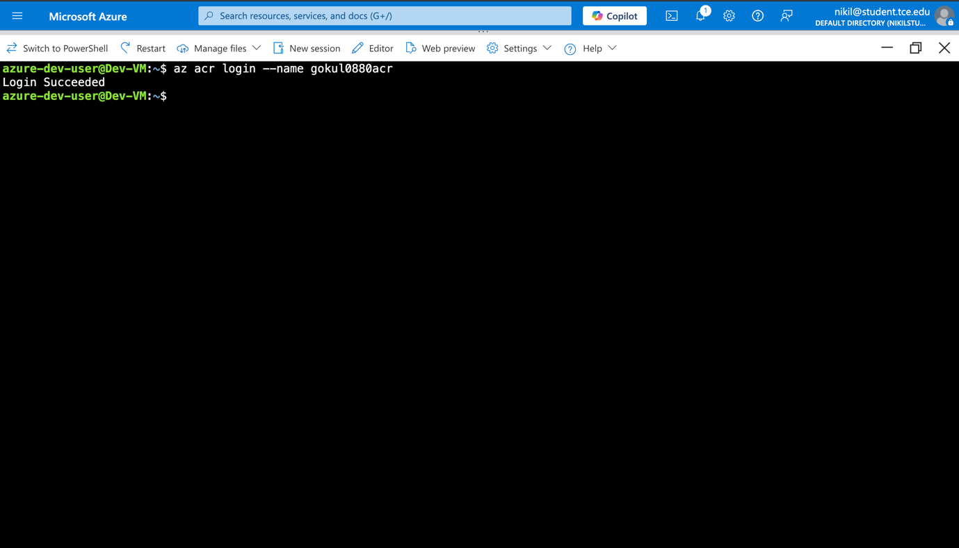

Azure ACR login

Integrated Azure CLI tools within the development VM to enable seamless interaction with Azure services. This setup provides programmatic access to Azure resources, enabling automated deployment workflows and resource management directly from the development environment.

### 6.3 Image Tagging and Push

**Commands Executed**:

docker tag hello-world-app gokul0880acr.azurecr.io/hello-world-app:latest

docker push gokul0880acr.azurecr.io/hello-world-app:latest

**Documentation**: Successfully tagged the local Docker image with ACR registry URL and pushed to Azure Container Registry. The tagging process:

* Renamed image to match ACR naming convention
* Applied 'latest' tag for version management
* Pushed image layers to secure cloud registry
* Verified image availability in ACR portal

This process creates a centralized, secure image repository accessible from Azure Kubernetes Service.

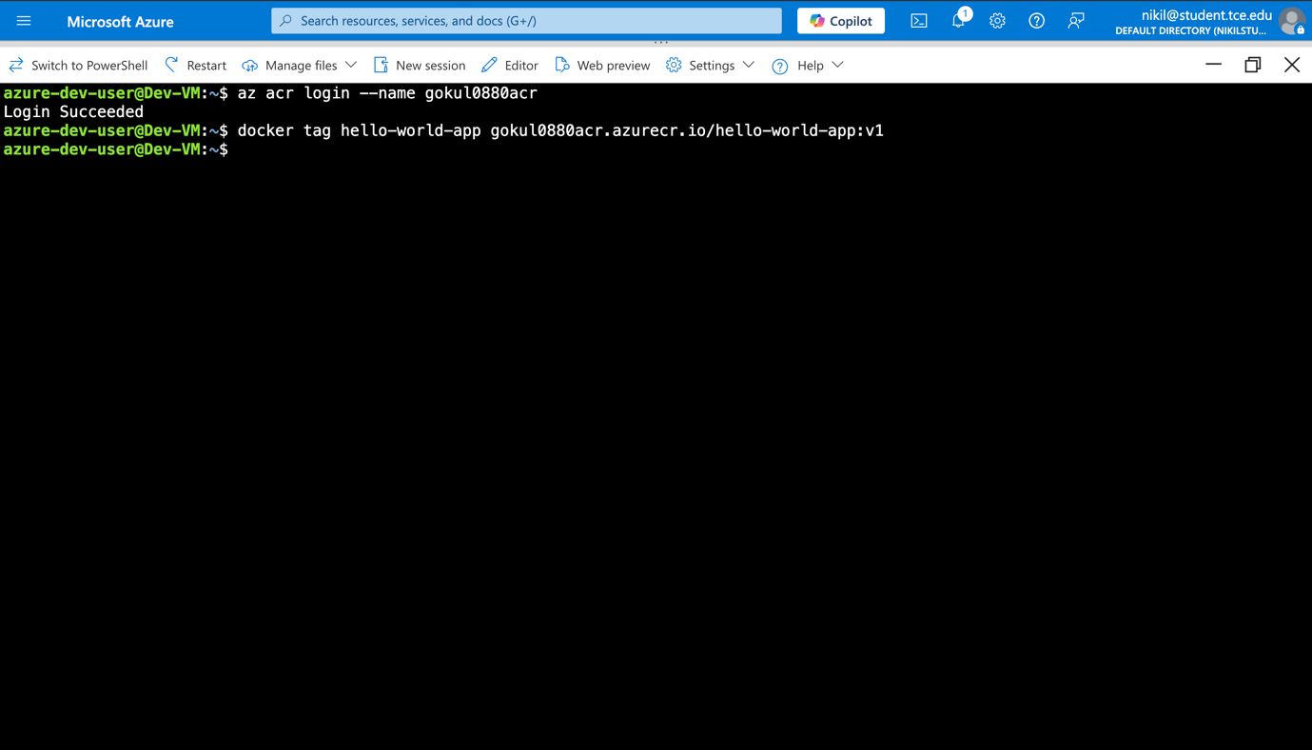

Tagged the ACR to the docker image

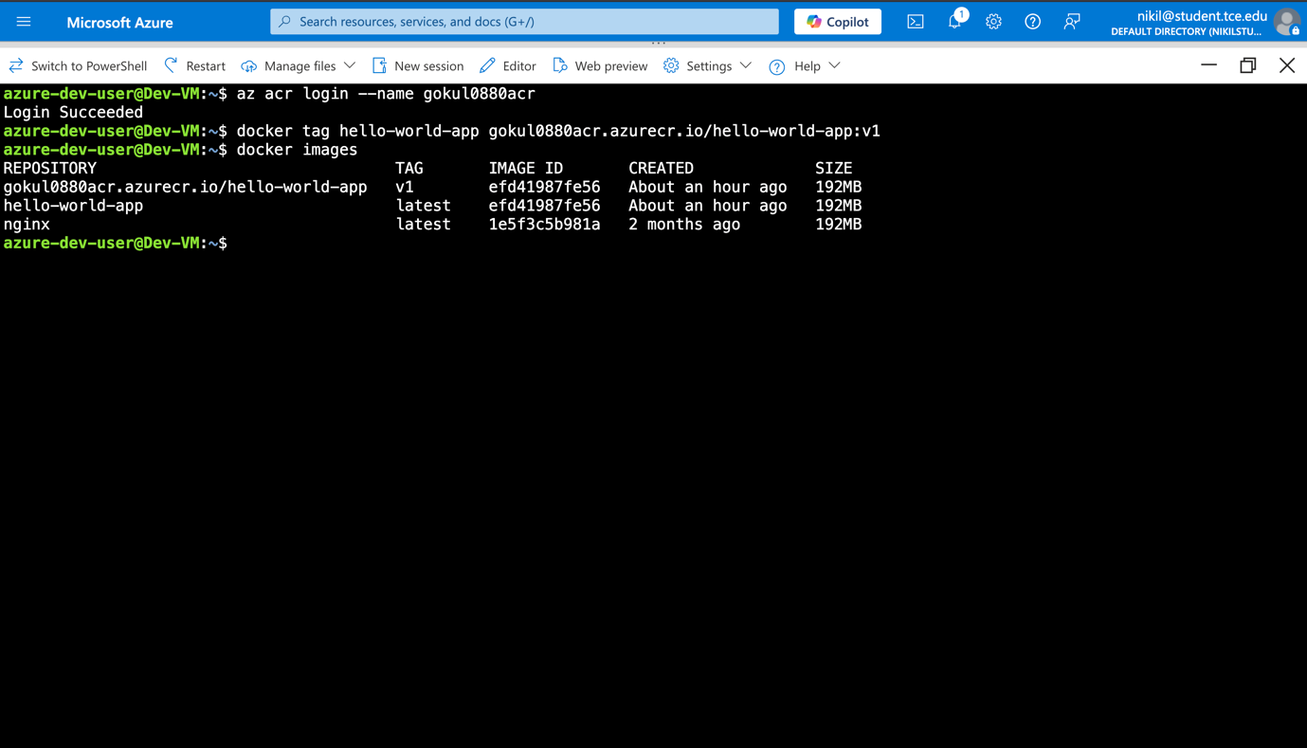 Tagged image visible in docker images list

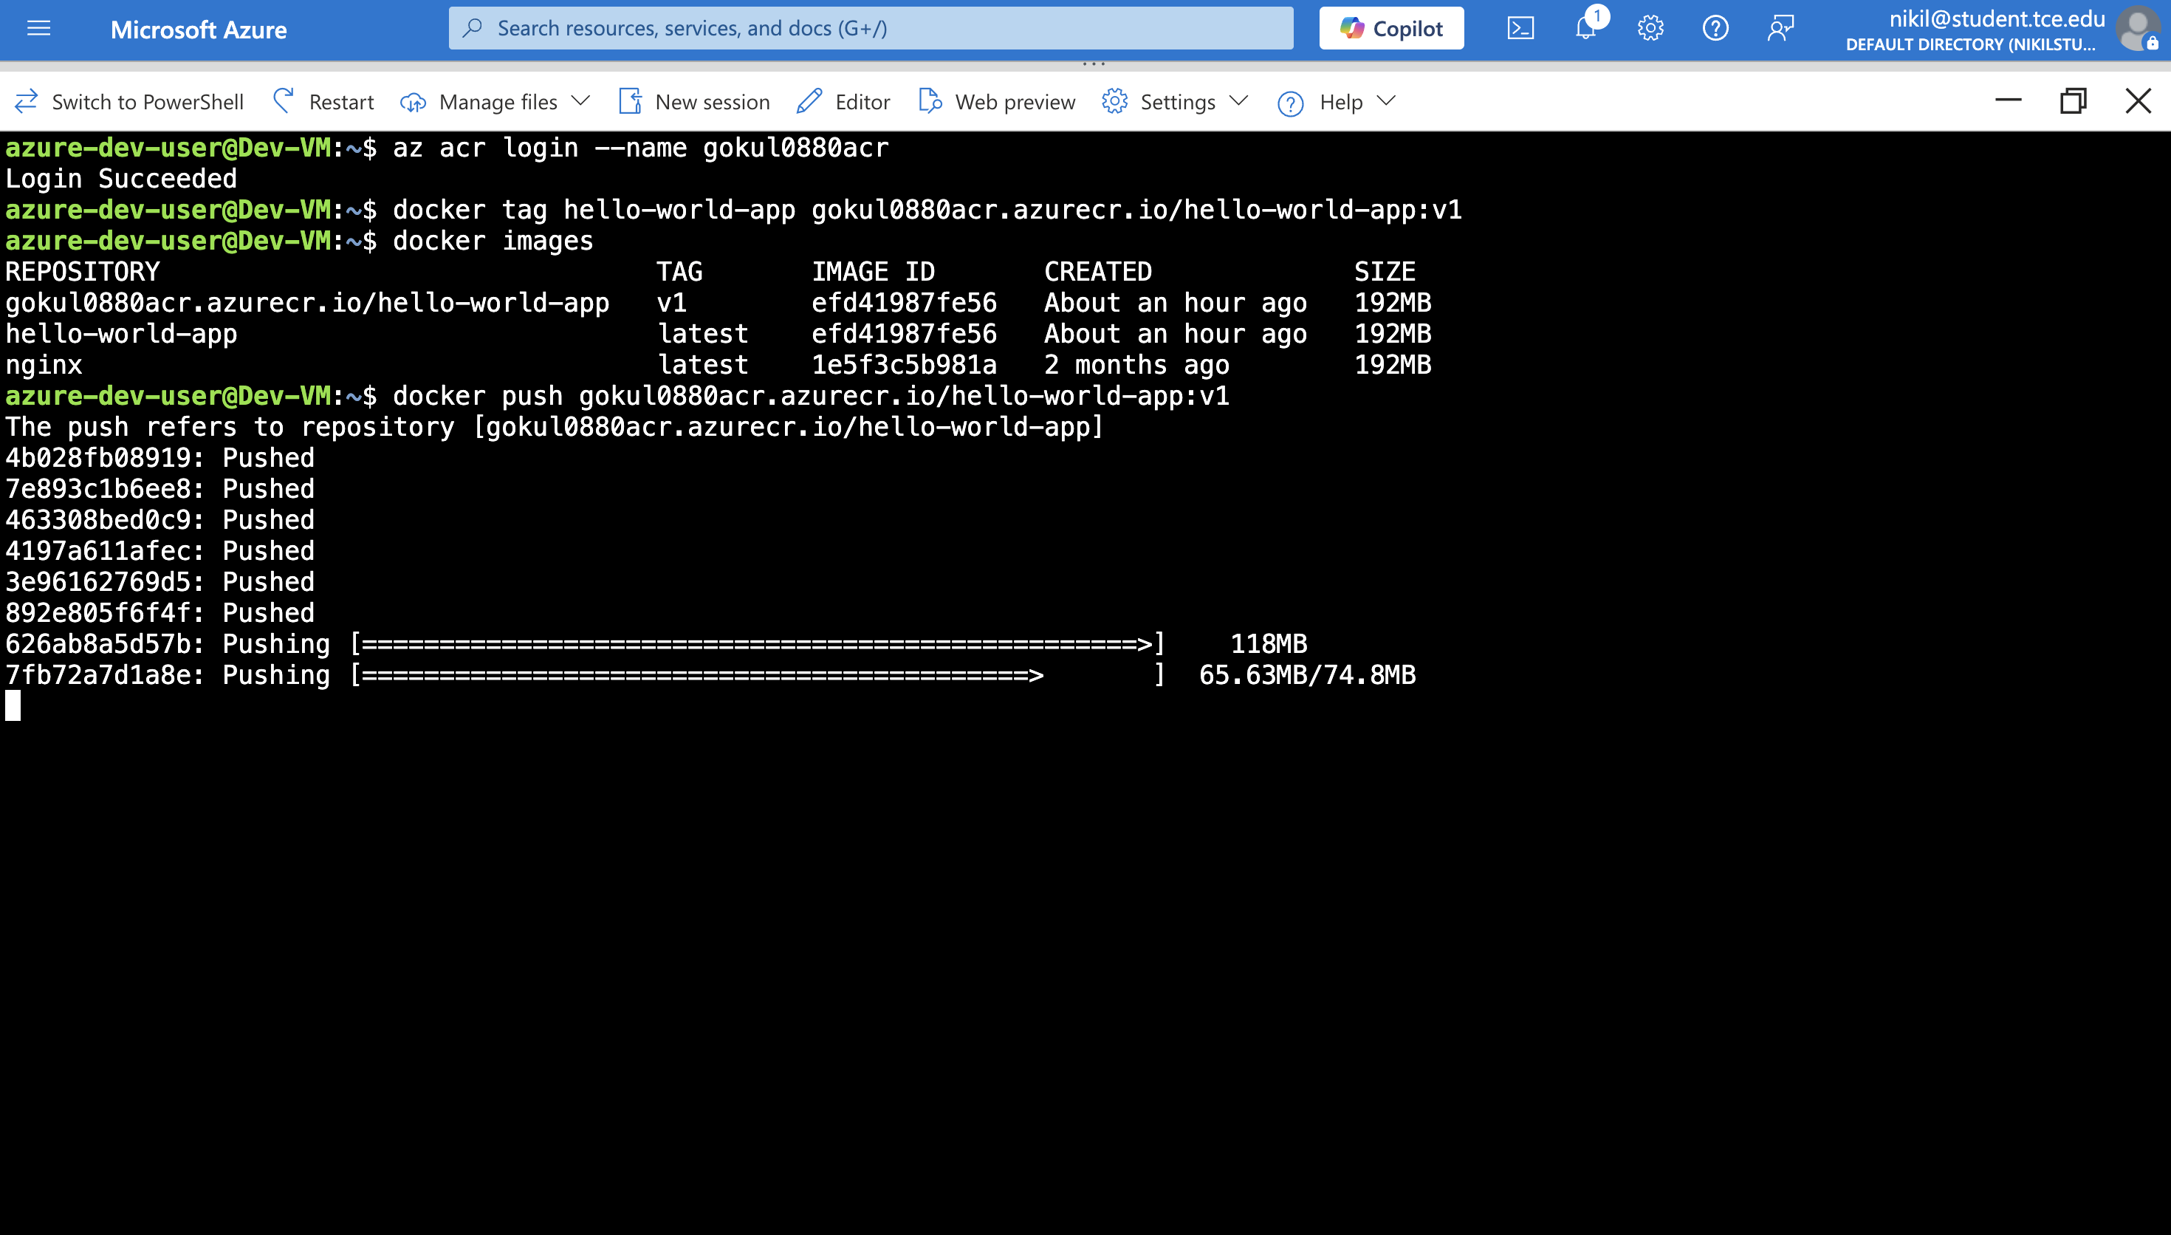

Image being pushed

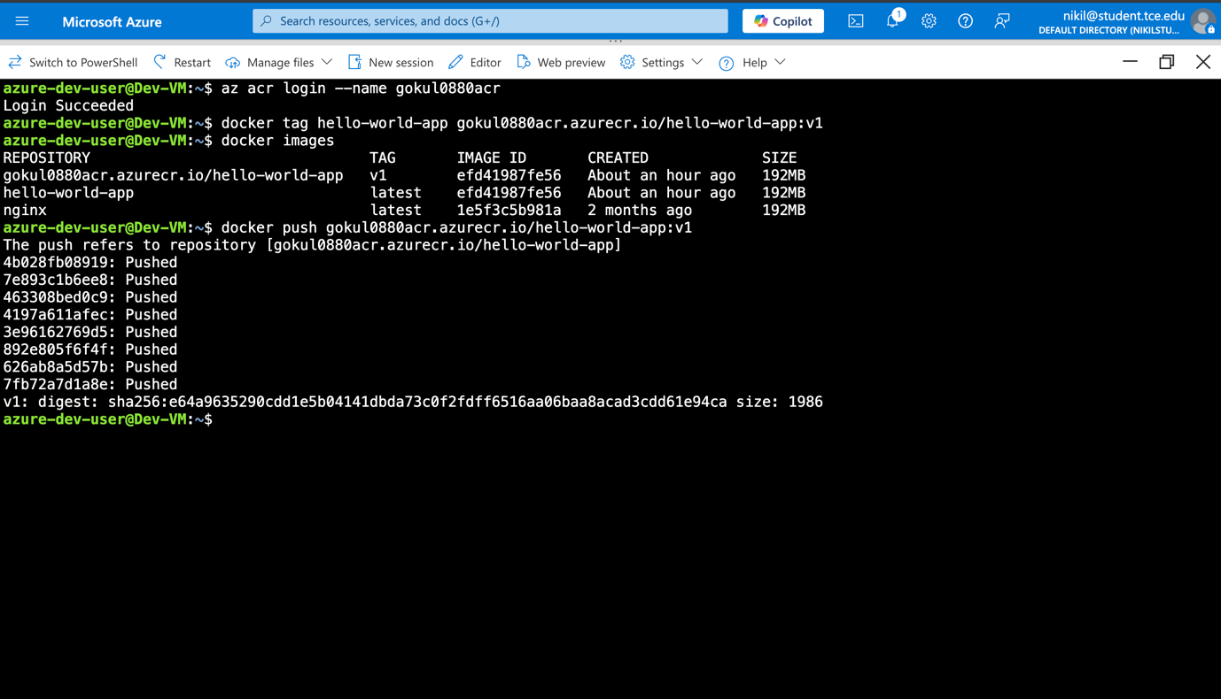

Done

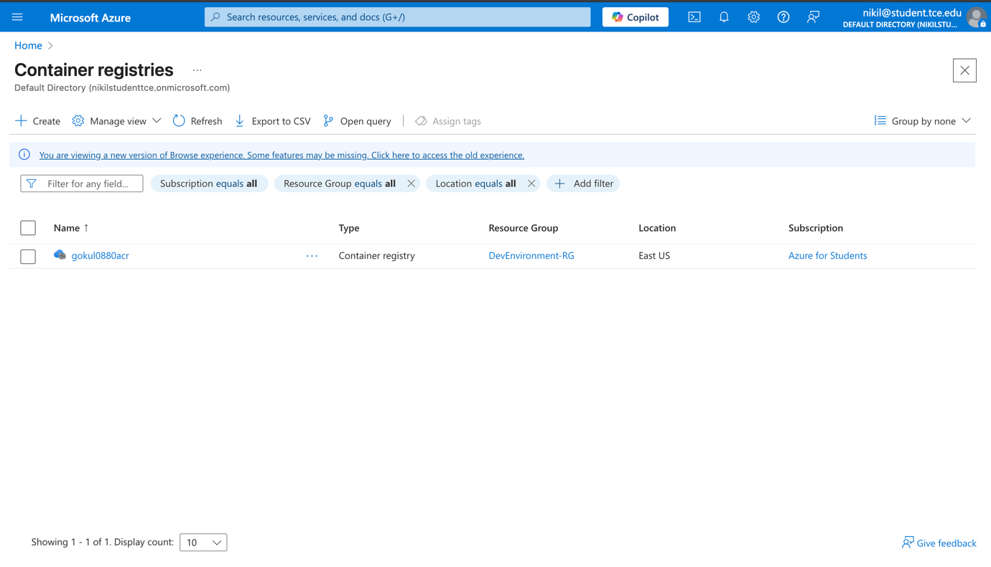

ACR page in Azure Portal

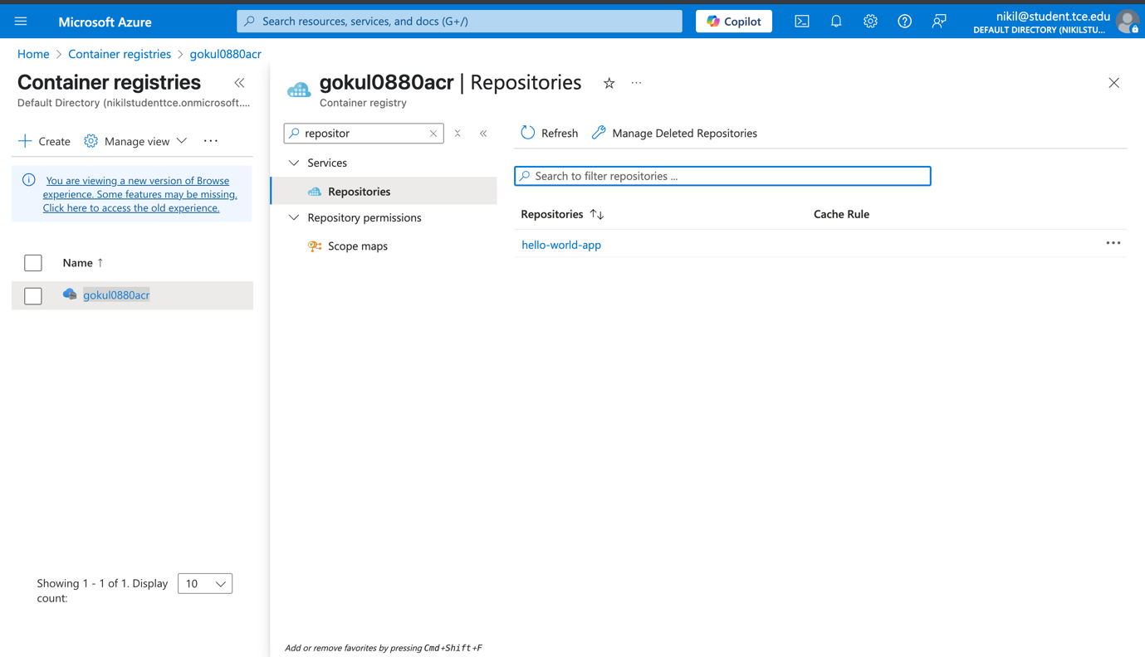

Repositories in gokul0880acr

## Phase 7: Azure Kubernetes Service Deployment

### 7.1 AKS Cluster Creation

**Command**:

az aks create \

--resource-group DevEnvironment-RG \

--name Dev-AKS \

--node-count 1 \

--enable-addons monitoring \

--generate-ssh-keys

**Documentation**: Created single-node AKS cluster optimized for development and free-tier usage. The configuration includes:

* **Node Count**: 1 (cost-effective for development)
* **Monitoring**: Enabled for cluster health insights
* **SSH Keys**: Auto-generated for node access
* **Network Integration**: Connected to existing VNet infrastructure

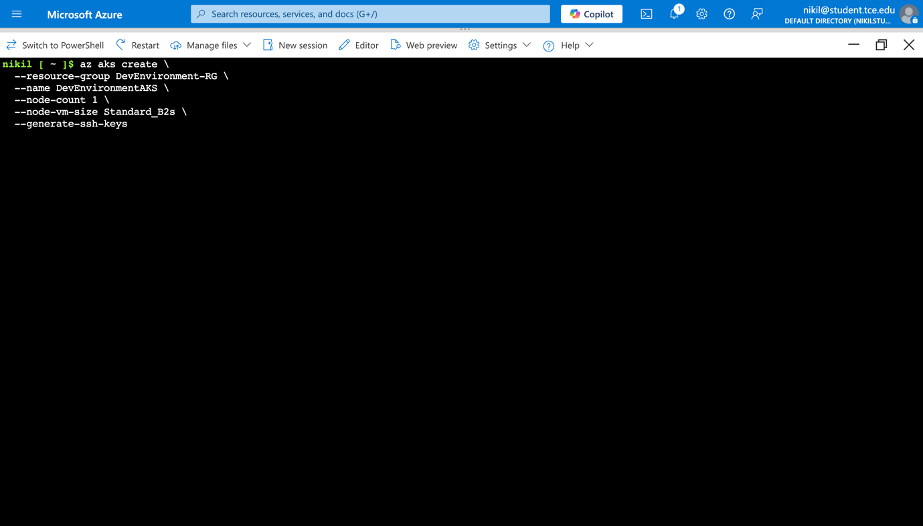

Create aks cluster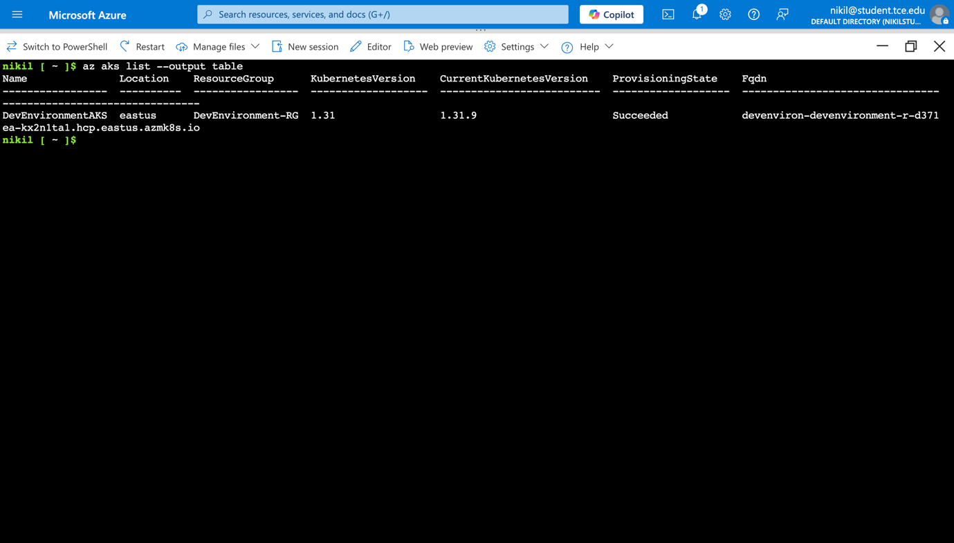

Cluster Created

### 7.2 ACR Integration with AKS

**Command**: az aks update -n Dev-AKS -g DevEnvironment-RG --attach-acr gokul0880acr

**Documentation**: Attached Azure Container Registry to AKS cluster, enabling secure image pulling without authentication credentials. This integration provides:

* Seamless image deployment from ACR to AKS
* Built-in security through Azure AD integration
* Simplified deployment process without manual credential management

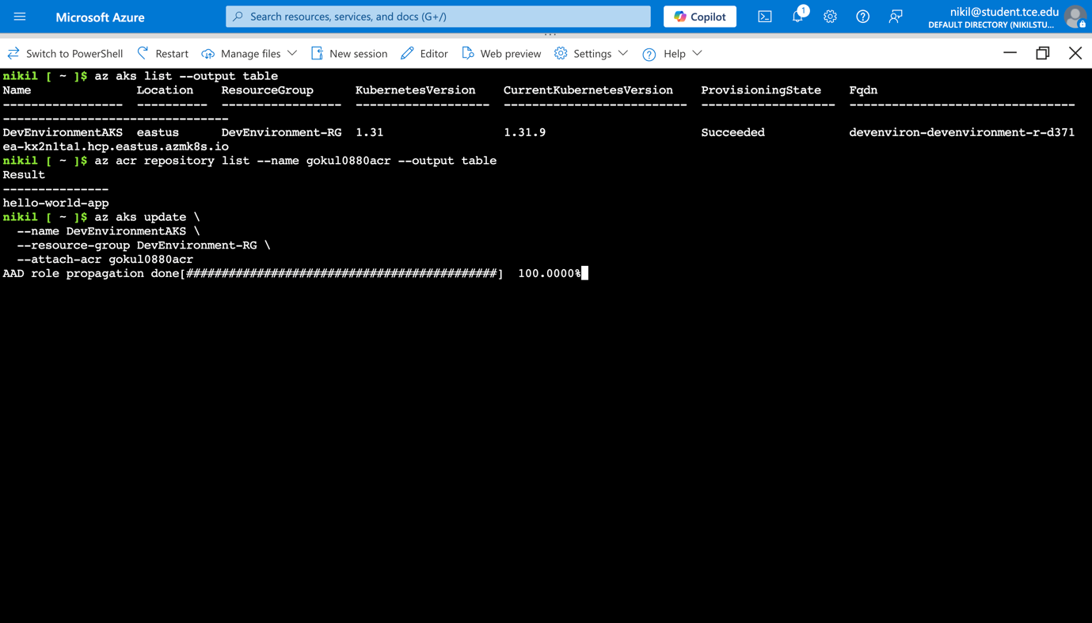

Attatched Cluster to ACR

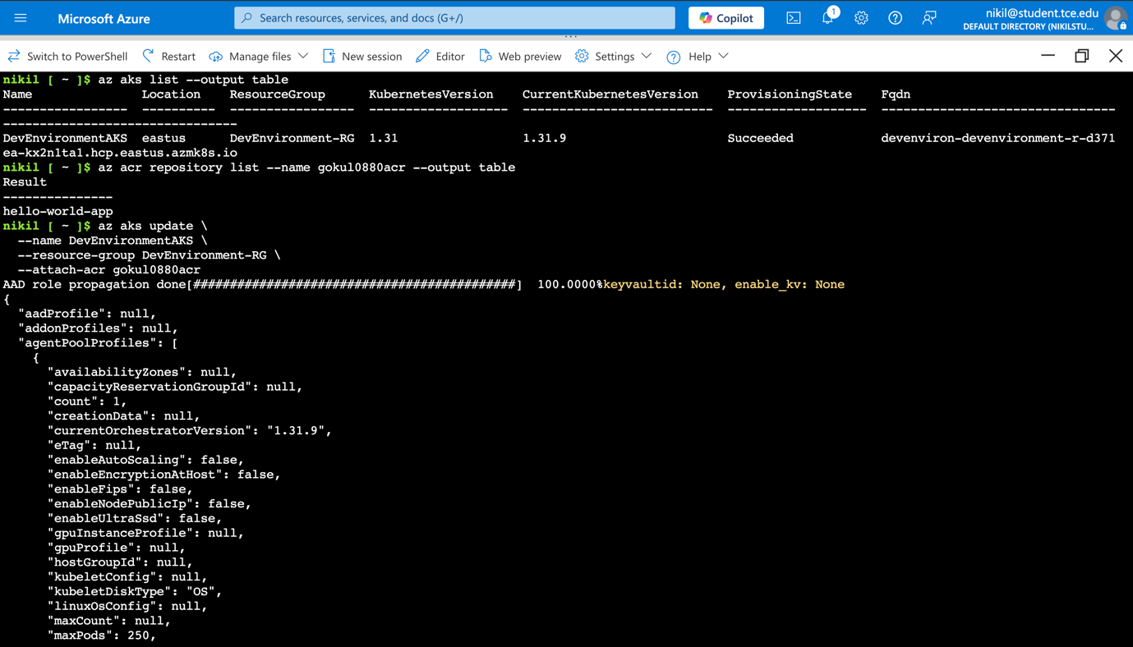

Successful

## Phase 8: Application Deployment

### 8.1 Kubernetes Deployment Manifest

**File**: deployment.yaml

yaml

apiVersion: apps/v1

kind: Deployment

metadata:

name: hello-world-app

spec:

replicas: 1

selector:

matchLabels:

app: hello-world-app

template:

metadata:

labels:

app: hello-world-app

spec:

containers:

- name: hello-world-app

image: gokul0880acr.azurecr.io/hello-world-app:latest

ports:

- containerPort: 80

**Documentation**: Created Kubernetes deployment manifest defining application deployment specifications:

* **Replica Count**: 1 pod for development environment
* **Container Image**: References ACR-hosted image
* **Port Configuration**: Exposes port 80 for web traffic
* **Label Selectors**: Enables service discovery and management

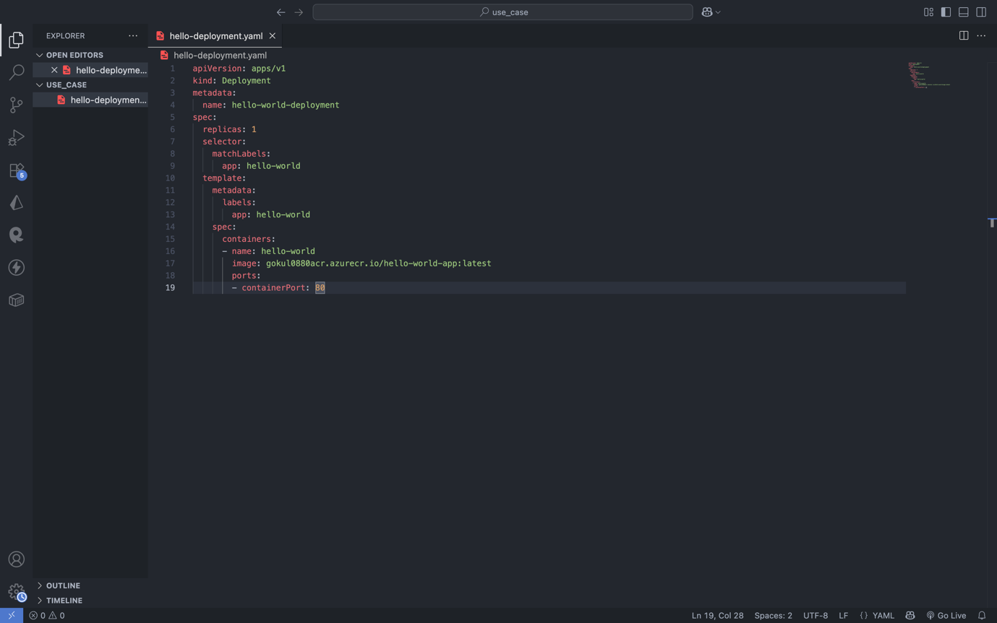

YAML File

### 8.2 Application Deployment

**Command**: kubectl apply -f deployment.yaml

**Documentation**: Successfully deployed application to AKS cluster. Kubernetes created:

* Deployment controller managing application lifecycle
* Pod running the containerized application
* Container pulling image from ACR
* Network configuration for internal communication

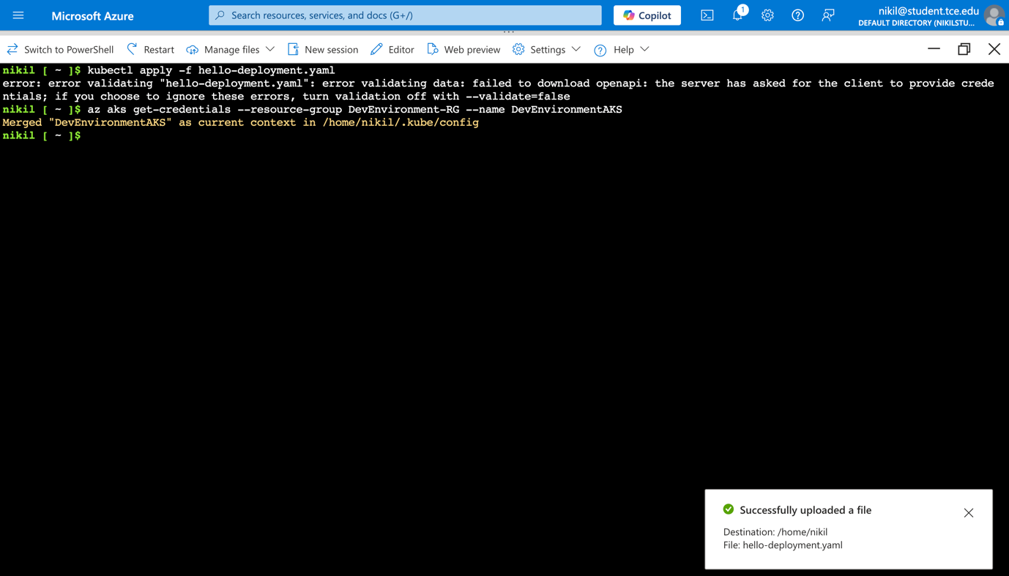

This will:

* Fetch cluster credentials.
* Configure your local kubectl context to talk to the AKS cluster.

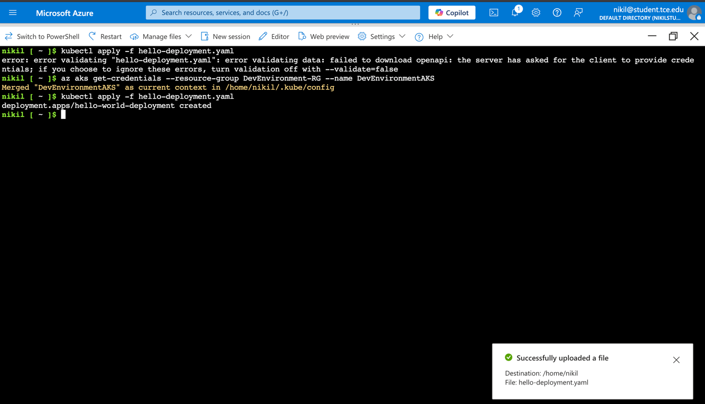

Cluster Created

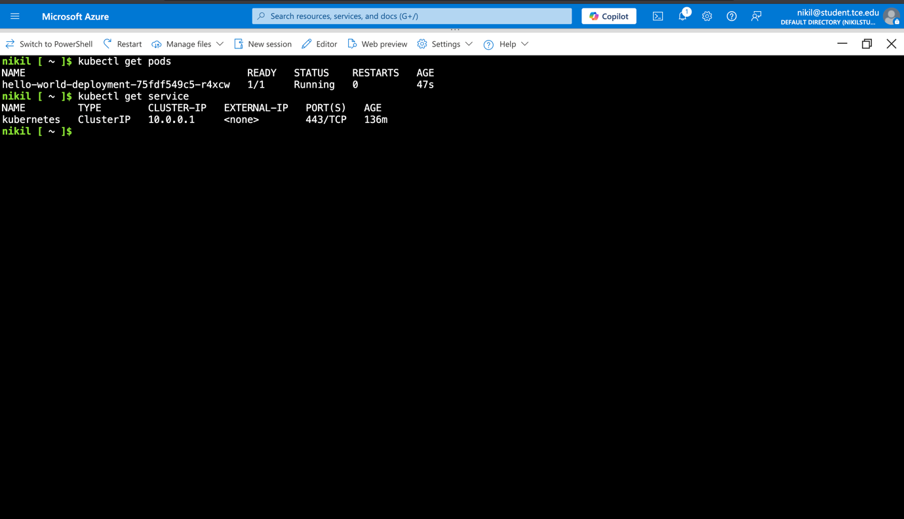

Application deployed into the pod

### 8.3 Service Exposure

**File**: hello-service.yaml

yaml

apiVersion: v1

kind: Service

metadata:

name: hello-world-service

spec:

selector:

app: hello-world-app

ports:

- protocol: TCP

port: 80

targetPort: 80

type: LoadBalancer

**Command**: kubectl apply -f hello-service.yaml

**Documentation**: Created Kubernetes LoadBalancer service to expose the application externally. The service configuration:

* **Service Type**: LoadBalancer for external access
* **Port Mapping**: Routes external port 80 to container port 80
* **Selector**: Targets pods with 'hello-world-app' label
* **External IP**: Azure provisions public IP for internet access

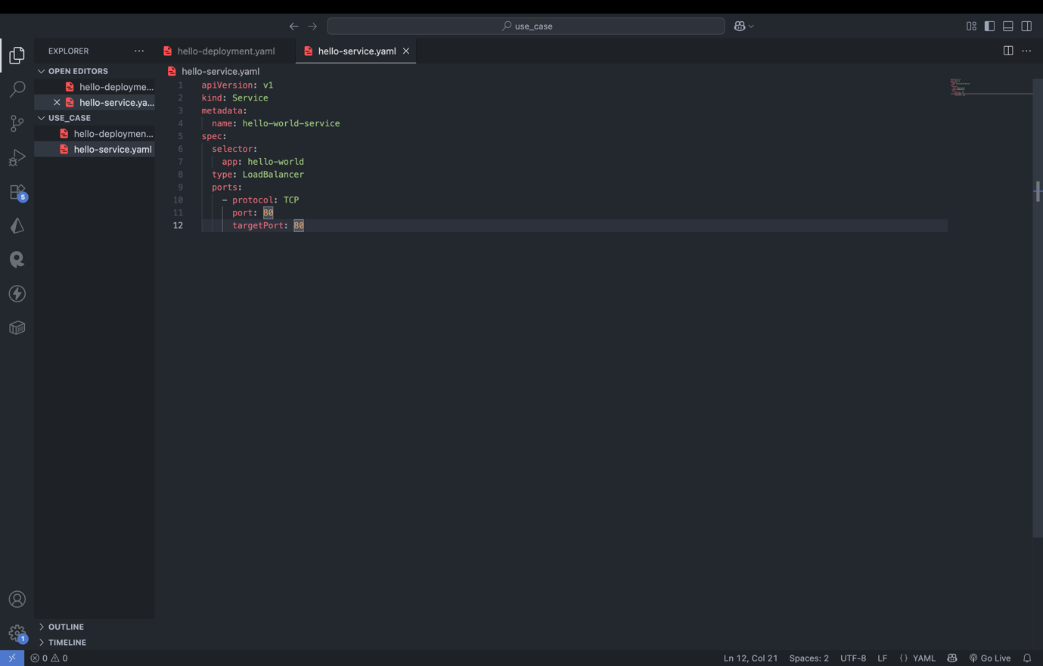

Hello-service.yaml

## Phase 9: Verification and Testing

### 9.1 Deployment Verification

**Commands Used**:

bash

kubectl get deployments

kubectl get pods

kubectl get services

**Documentation**: Verified successful deployment through Kubernetes status commands:

* **Deployments**: Confirmed deployment is available and ready
* **Pods**: Verified pod is running and healthy
* **Services**: Confirmed LoadBalancer service has external IP assigned

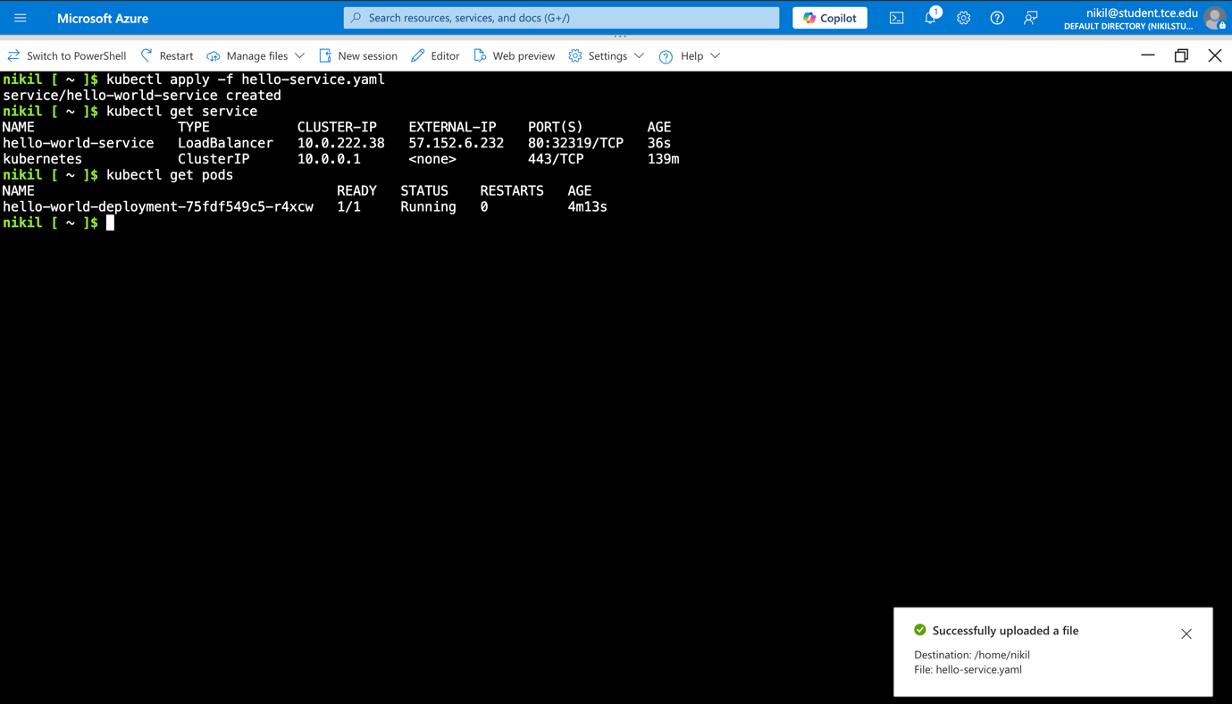

Exposed.

### 9.2 Application Access

**Access Method**: External IP address provided by LoadBalancer service

**Documentation**: Successfully accessed the "Hello World" application through the external IP address. The application loaded correctly, displaying:

* Proper HTML rendering
* CSS styling applied correctly
* Responsive design functioning
* Welcome message visible

This confirms end-to-end deployment success from development to production.

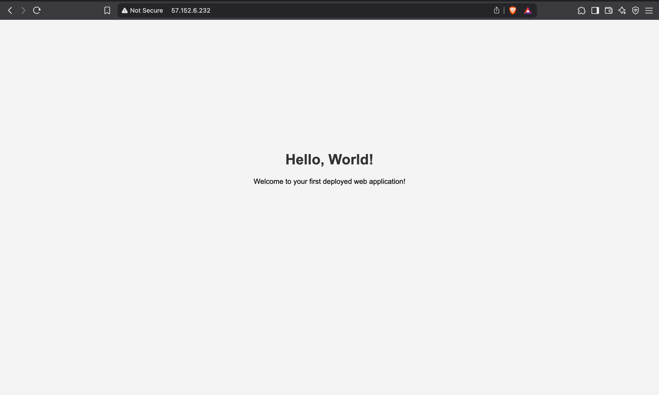

Application Deployed.

## Phase 10: Resource Management

### 10.1 Resource Cleanup

**Command**: Resource group deletion for complete cleanup

**Documentation**: Implemented proper resource management by cleaning up all created resources. This demonstrates:

* Cost management awareness
* Proper DevOps practices
* Resource lifecycle understanding
* Azure Free Tier optimization

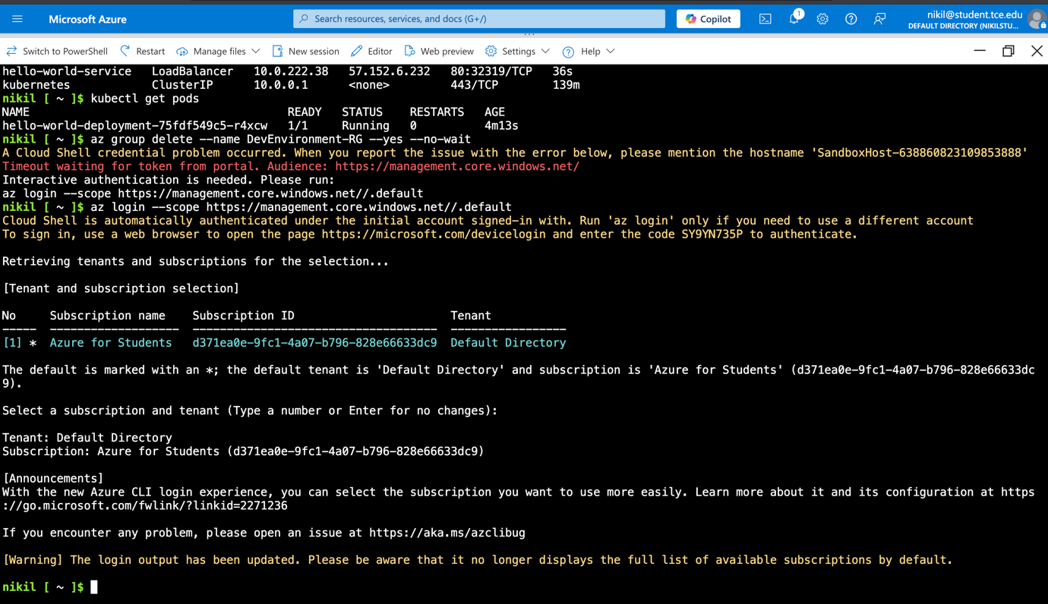

Delete resources.